

Operation Manual

PSW-1-45-WiFi

Multifunctional Unmanaged Switch
for IP Video Surveillance Systems

Version 5

 | Power supply elements are under high voltage. It is strictly forbidden to touch conducting elements of the power supply unit under voltage.
 | Before connecting a laptop to port 5 of the switch, put Passive PoE jumpers into the OFF position.

For effective lightning protection the following is required:
- proper grounding made according to the Electrical Code;
- a shielded twisted pair with shielded RJ45 connectors;
- minimum length of the twisted pair and power supply cables.

Contents
Contents 1
1. Designation 3
2. Features 5
3. Description.……………………………………………………………………5
3.1. Appearance 5
3.2. Components layout 6
3.3. PoE power supply 7
3.4. Lightning protection 7
3.5. Restarting cameras in case of hanging 8
4. Technical parameters 9
5. Operating conditions 9
6. Installation 10
6.1. Unit mounting 10
6.1.1. Wall mounting 10
6.1.2. Mounting on the pole 11
6.1.3. Installation into TFortis CrossBox cabinet 11
6.2. Power supply connection 12
6.3. Connecting the cameras and access point 12
7. Manufacturer's warranty 13
8. Technical support……………………………………………………………13

1. Designation

PSW-1-45-WiFi switch is an unmanaged outdoor Fast Ethernet switch used for the construction of IP video surveillance networks.

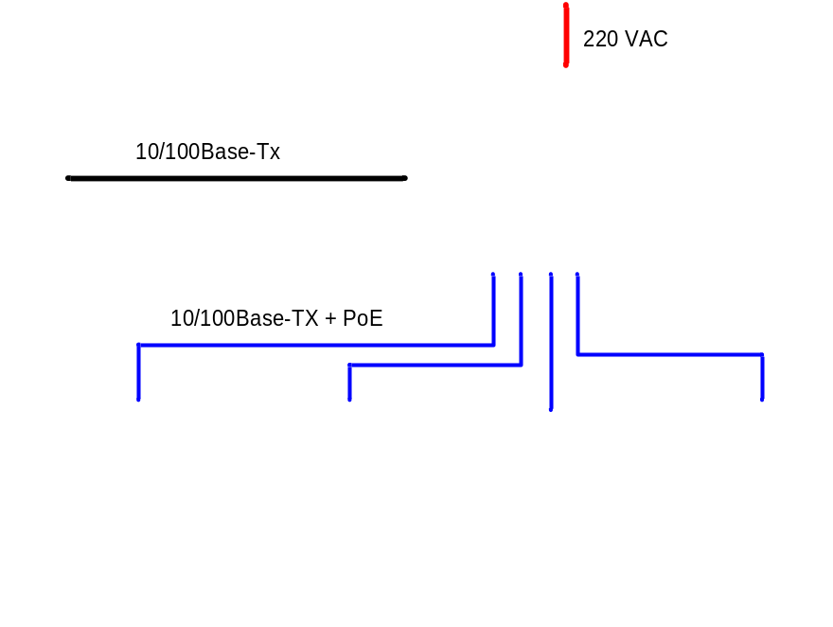

Figure 1-1. PSW-1-45-WiFi switch, connection over twisted pair

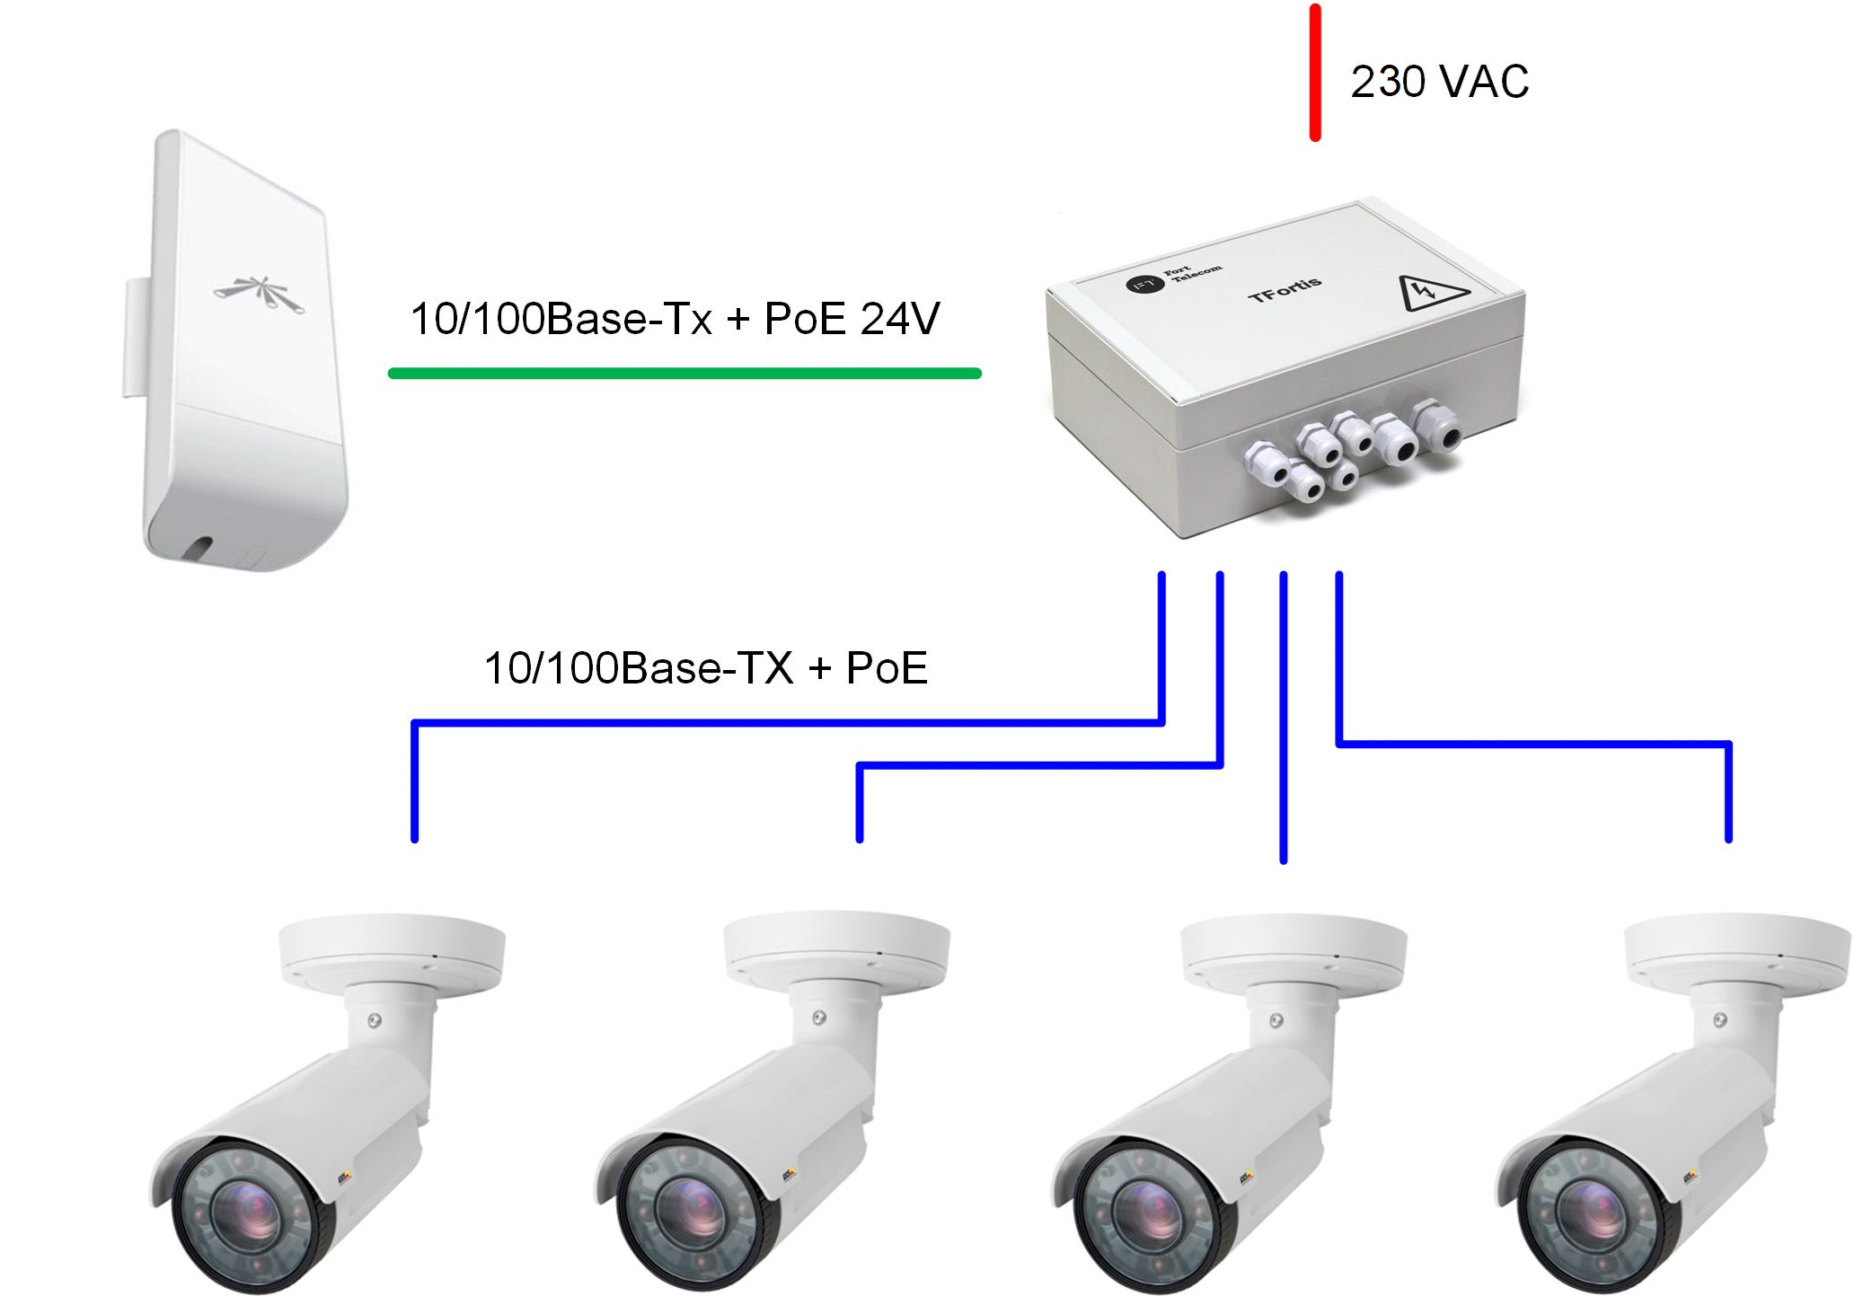

Figure 1-2. PSW-1-45-WiFi switch, connection over Wi-Fi

2. Features

Weatherproof design
The switch body is made of technopolymer resistant to severe operating conditions. Dust and moisture protection rating IP66.

Operation in extreme temperatures
The switch comprises industrial hardware components with a wide range of operating temperatures. Application of industrial SFP modules will ensure normal operation in the temperature range from –60°C to 50°C * and above up to 65°C with less load.
*The maximum temperature depends on the load (see diagram in section 4. Operating conditions)

PoE support (IEEE802.3af)
The switch may supply PoE to any camera compliant with IEEE802.3af standard. Power is supplied through free pairs (either [1,2 and 3,6] or [4,5 and 7,8]). The mode of power supply is defined by jumpers.

Passive PoE support (24V)
Port №5 supports Passive PoE 24V, which allows to connect wireless access points such as Ubiquiti or MikroTik, LTE and 3G routers.

Connection to 230VAC
A built-in power supply unit ensures direct connection of the switch to 230VAC power supply eliminating the need for an additional power supply unit.

Lightning protection
A built-in lightning protection for Ethernet ports and 230VAC power supply protects the switch and connected cameras from surges caused by electrostatic discharges.

Circuit breaker compartment
The switch has a circuit breaker compartment, which eliminates the need for additional cabinets or boxes.

Automatic cameras restart in case of hanging
The switch controls operation of the cameras. In case of hanging, the switch will reboot the camera automatically over PoE. It allows to create unattended IP video surveillance networks.

3. Description

3.1. Appearance

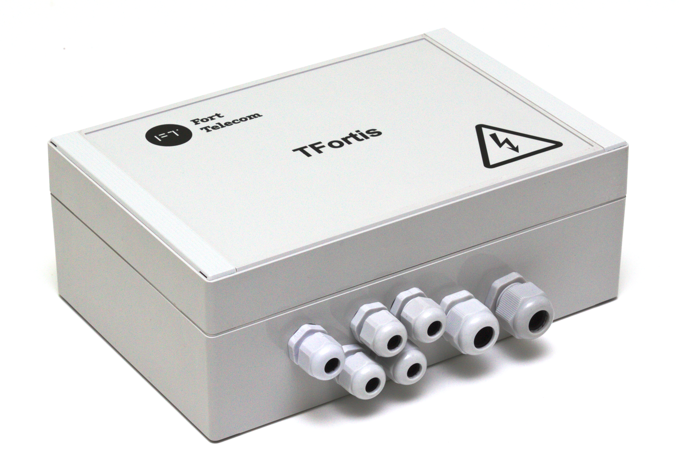

Figure 3.1-1. PSW-1-45-WiFi switch, exterior view

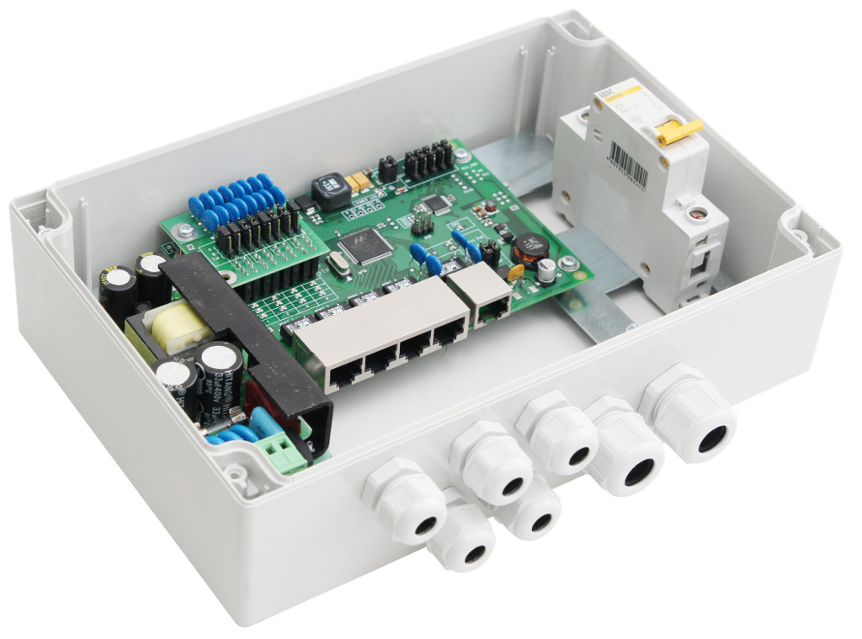

Figure 3.1-2. PSW-1-45-WiFi switch, interior view (circuit breakers are not included)

3.2. Components layout
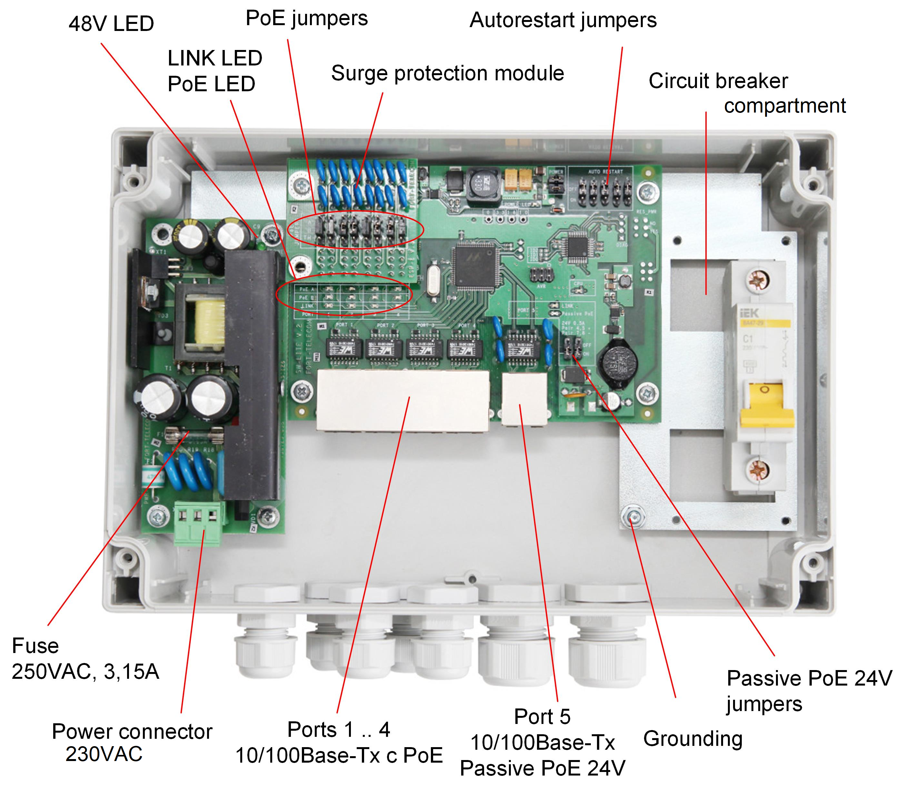

Figure 3.2. Layout of components inside PSW-1-45-WiFi switch

During normal processor operation, CPU indicator should blink in 2-second intervals (1 second ON, 1 second OFF).

3.3. PoE power supply

PSW-1-45-WiFi switch supports the following types of power supply:
- IEEE802.3af power supply for ports No.1 to 4,
- Passive PoE 24V (pairs 4,5 and 7,8) for port 5.

Passive PoE on port 5 is activated by the jumper. Before connecting a laptop to port 5, put Passive PoE jumpers into the OFF position.

3.4. Lightning protection

PSW-1-45-WiFi switch has built-in lightning protection modules that protect Ethernet ports and 230VAC power circuits from common-mode and differential electromagnetic interferences.
The switch is resistant to powerful microsecond pulse interferences according to GOST R 51317.4.5 standard with the degree of severity according to Table 3.4-1, performance criteria B.
The switch is resistant to AC transients in the power supply circuit according to GOST R 51317.4.11 standard, Table 3.4-2, performance criteria B.

Table 3.4-1.
Port | Degree of severity according to Table 1, GOST R 51317.4.5 | Voltage surge value, kV+ 10%
Wire-to-wire power supply circuits | 3 | 2
Wire-to-ground power supply circuits | 4 | 4
Wire-to-ground balanced communication circuits | 3 | 2

Table 3.4-2.
Type of impact | Degree of test severity | Test voltage,  % Un, + 5 % | Voltage transients  amplitude, % Un | Voltage transients  duration, intervals (ms)
Voltage dips | 1 | 70 | 30 | 10 (200)
Voltage interruptions | 1 | 0 to 20 | 100 | 1 (20)
Voltage surges | 2 | 120 | 20 | 25 (500)
Note: Un is the nominal power supply voltage.

("Performance criteria B" means temporary disruption of performance or functioning with further recovery without operator's intervention)
Continued operation with changes in the supply voltage from ~187 to ~253V.

3.5. Restarting cameras in case of hanging

PSW-1-45-WiFi switch continuously monitors traffic intensity of the camera. If network activity is lost, the switch will reboot the camera by disconnecting PoE power supply. This function is activated by a jumper for each particular port.

4. Technical parameters

Ports No. 1 to 4
- 10/100Base-Tx – 4 pcs;
- IEEE802.3af support – 15.4 W per port;
- Auto-MDIX support;
- IEEE 802.3x flow control support;
- PoE and data transfer distance – up to 100 m.

Port 5
- 10/100Base-Tx – 1 pc;
- Passive PoE 24V support (pairs 4,5 and 7,8) – 24V, 0.5A;
- pairs 4,5 "+", pairs 7,8 "–"
- Auto-MDIX support;
- IEEE 802.3x flow control support;
- PoE and data transfer distance – up to 100 m.

Power supply
- PSU voltage 230VAC (187 to 253V);
- PoE power budget – 50W maximum;
- maximum power consumption – 60W.

Design
- dimensions – 240x160x90 mm;
- maximum weight – 2 kg;
- IP66 casing;
- cable glands
– 4-8 mm cable – 5 glands
– 6-12 mm cable – 2 glands

Reliability
- meantime between failures – at least 50 000 hours (5,7 years).

5. Operating conditions
PSW-1-45-WiFi switch is designed for 24/7 outdoor operation at the ambient temperatures from –60 to +50°C* and above up to +65°C with less load (see diagram).
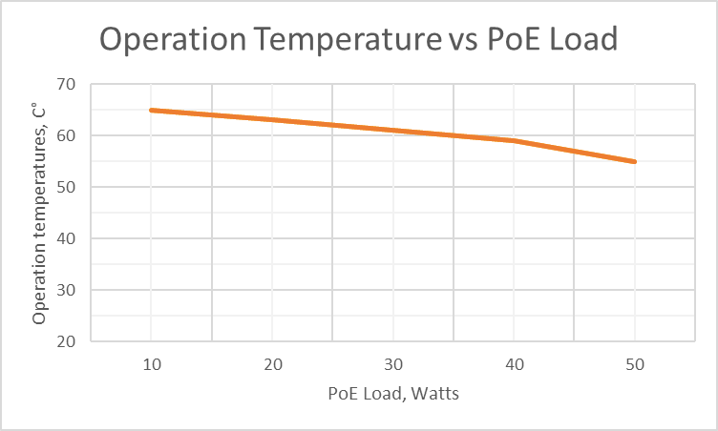
*The maximum temperature depends on the load (see diagram)

Note 5.1.
PSW-1-45-WiFi switch maintains declared parameters at storage temperatures from -60 C to +50 C.

It is recommended to install the switch in places protected from direct sunlight (for example, under canopies, on the shady side of buildings)

6. Installation

6.1. Unit mounting

6.1.1. Wall mounting
The housing has four attachment points at the edges. Marking of the attachment points is shown in Figure 6.1.1.

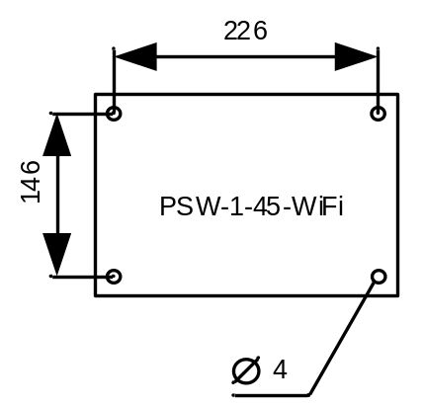
Figure 6.1.1. Attachment points marking

WARNING! Drilling of the housing will lead to loss of the switch integrity and, as a result, loss of product warranty.

6.1.2. Mounting on the pole

To install PSW-1-45-WiFi switch on the pole, use TFortis support bracket for PSW.

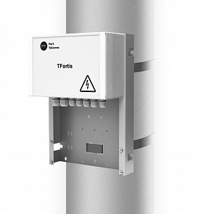

Figure 6.1.2. Mounting the switch on the pole

6.1.3. Installation into TFortis CrossBox cabinet

TFortis PSW-1-45-WiFi switches have a hermetically sealed enclosure of technopolymer providing IP66 protection rating. This ensures safe outdoor installation without the need for an additional metal enclosure. To provide extra protection from vandals, a TFortis CrossBox cabinet may be used.
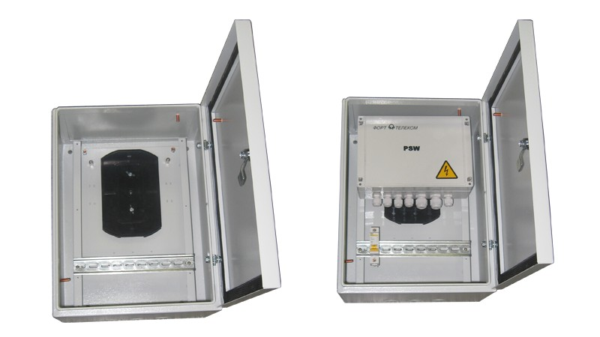

Figure 6.1.3. TFortis CrossBox-1 cabinet with a PSW-1-45-WiFi switch

6.2. Power supply connection

PSW-1-45-WiFi switch is connected to 230VAC power supply. Power supply cable is pulled into the unit trough a cable gland and is connected to the power supply terminal block either directly or via a circuit breaker assembly.

WARNING! Grounding of the switch is required. Grounding resistance should not exceed 4 Ohm.

WARNING! Energized high-voltage conductors should never be in contact with circuit boards. The resulting failure will lead to loss of product warranty.

WARNING!
The switch contains static power supply units and, therefore, is a reactive load. Inrush currents that occur during charging of the input capacitors will exceed nominal current values. To prevent false tripping of the circuit breakers, it is recommended to choose models with characteristic C and at least 4A current.

6.3. Connecting the cameras and access point
It is recommended to use a 4-pair shielded cable, at least category 5. Ethernet cable is pulled into the switch through a cable gland, clamped and connected to RJ45 ports. For more convenient clamping, a cable gland may be removed and then re-installed. Unused cable glands should be sealed off.
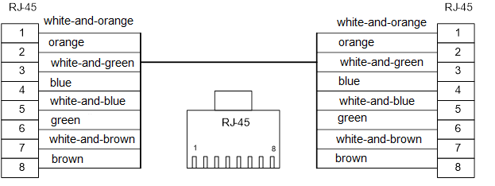

Figure 6.3.1 Cable termination.

7. Manufacturer's warranty

The warranty period for the switch is 36 months from the date of sale. Only a complete switch is accepted for servicing and repair.
Warranty shall not apply in the following cases:
- if the warranty period has expired;
- if manufacturer's marking with the serial number on the housing is missing or if the serial number has been changed, removed or is illegible;
- if there are internal or external mechanical damages (chipping, cracking, deformation, damaged power supply wires, cracking or splitting of the terminals), signs of treatment with aggressive chemicals or fluids, severe contamination, insects presence or signs of insects presence;
- in case of improper connection and operation of the switch or if power supply parameters do not meet the requirements specified in this operating manual;
- if the switch was damaged as a result of force majeure, due to the actions of third parties or other reasons beyond manufacturer's control.

8. Technical support

Technical support for the design of video surveillance systems, issues of operation and configuration of equipment is provided by email tfortis@fort-telecom.ru

Technical documents are available on the website https://tfortis.com/support/dokumentaciya-na-produkciyu/

