Operation Manual
PSW-11

Multifunctional Gigabit Switch for IP- video surveillance systems

Version 7
Components of power supply units are under high voltage. Touching conducting components of active power supply units is forbidden.
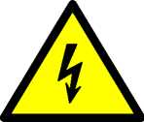
When connecting the computer to the switch, remove PoE jumpers at this port.
For effective operation of lightning protection is required:
- high quality grounding according to the ELC;
- use of shielded twisted pair with shielded connectors RJ45;
- Minimization of twisted pair and power cable length;
Table of Contents

1. Designation 4
2. Description 6
2.1. Appearance 6
2.2. Element arrangement 7
2.3 Power supply over PoE 8
2.4 Optical port 10
2.5 Lightning protection 10
2.6 Cold start 11
2.7 Restart of video cameras at their hanging 12
3. Technical parameters 12
4. Operation conditions 12
5. Presetting 13
5.1. Configuring PoE on port 13
5.2. Speed mode configuration for SFP port 13
5.3. Enabling Preheating of camera housings 13
6. Device installation 14
6.1. Unit mounting 14
6.2. Optic connection 14
6.3. Power connection 15
6.4. Connection of video cameras 15
7. Manufacturer’s warranty 16

1. Designation
Device PSW-11- is a Multifunctional Gigabit Switch in street version designed for connection of one IP-camera by optics. This switch has two ports. First port is optical, the second - copper. The optical port is designed to connect it to other switches (media converters), the second - to connect the video camera.
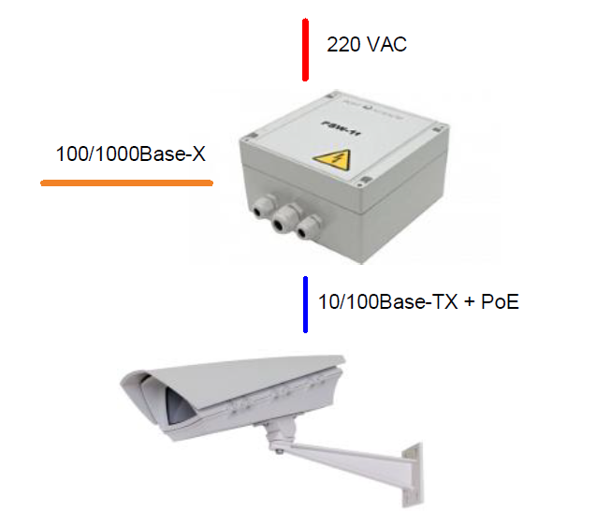
Figure 1. Connection Scheme of the PSW-11
Weatherproof version
The body of the device is made of a techno-polymer that is resistant to Stringent Operating Conditions. There is a protection from moisture and dust IP66.

Operation in extreme temperatures
The device has industrial hardware components that are characterized by an extended temperature range. Using industrial SFP modules in industrial version guarantees operation from -60°C to 50°C.
Optical port speed selection
You can select optical port speed (1000M or 100M) with the jumper.

PoE Support
The switch can power any PoE-camera that supports IEEE802.3af standard.
Power supply for Camera housings over PoE
Switch operating with TFortis TH Camera housings powers both video camera (IEEE802.3af) and Camera housing (Passive PoE) via twisted pair.
Connection to 230V
Built-in PSU provides direct connection of the switch to the Power Supply 230VAC and excludes need in additional PSU.
Lightning protection
Built-in Lightning protection of Ethernet ports and 230VAC PSU reliably protects both the switch and connected video cameras from pulse disturbances induced by lightning discharges.
Cold start
Preheating of camera housings provides safe and guaranteed turn-on of video cameras in cold conditions.
Automatic restart of video cameras at their hanging
The switch controls operation of video cameras. If video camera is hanging, switch restart it automatically over PoE. This allows constructing non-attended IP- video surveillance systems.

2. Description

2.1. Appearance
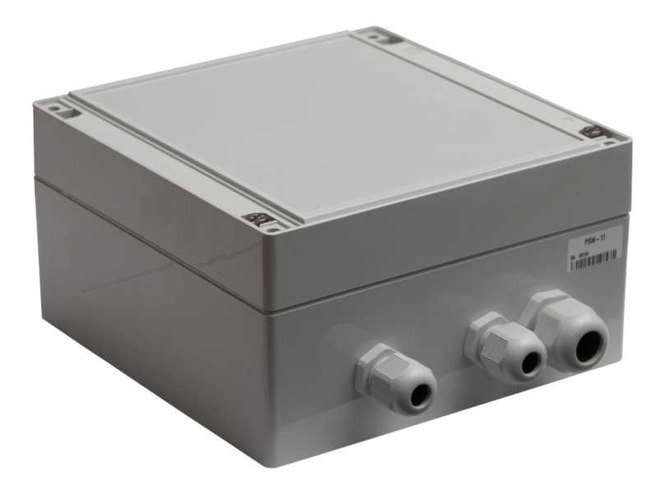
Figure 2.1-1. PSW-11- outside view
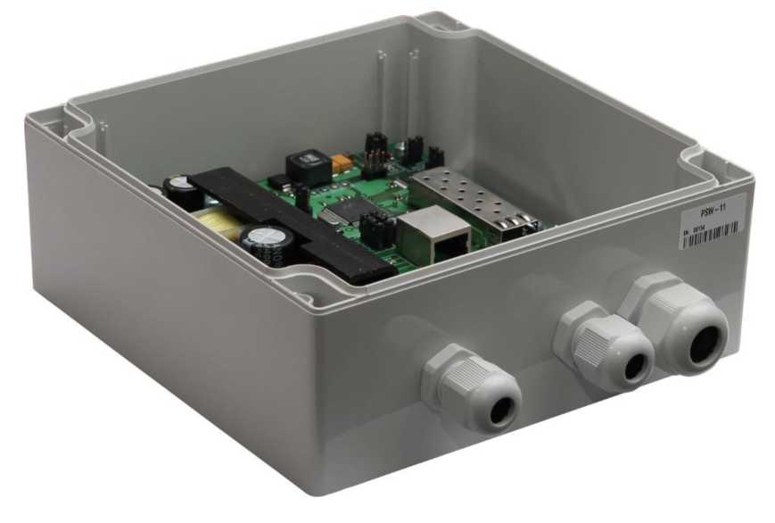
Figure 2.1-2. PSW-11 - inside view

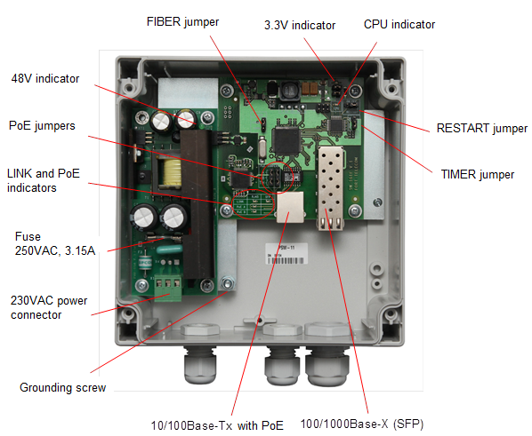
- Element arrangement

Figure 2.2-1. Element arrangement of PSW -11
During normal operation, CPU indicator must light intermittently with a frequency of 2s. (1 sec. - on, 1 sec. - off)
  - Power supply over PoE
The switch PSW-11 maintains power supply through IEEE802.3af and Passive PoE technology. Power supply is selected according to jumper configurations (Table 2-3). Power is supplied through pairs 1,2 and 3,6 over data or through free pairs 4,5 and 7,8. In the PoE standard terminology, first one is named as mode A and the second - mode B. Power is supplied to video cameras installed into TFortis TH camera housing using mode A and mode B simultaneously (I). When you connect other devices (not PoE), remove jumpers for relevant port (IV).
Table 2-3. Configuration of PoE jumpers
 | Pairs 1,2 and 3,6 | Pairs 4,5 and 7,8 | Figure
 | IEEE802.3af  (video camera) | Passive PoE (TFortis TH camera housings) | I
 | IEEE802.3af  (video camera) | - | II
 | - | IEEE802.3af  (video camera) | III
 | - | - | IV

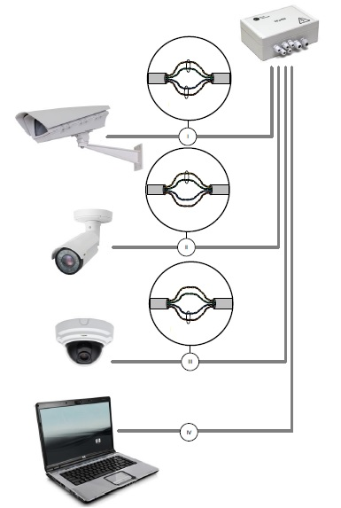

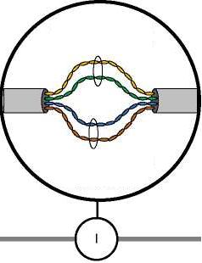
Pairs 1,2 and 3,6
IEEE802.3af

TFortis TH camera housing

Pairs 4,5 and 7,8
Passive PoE

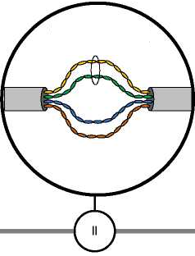
Pairs 1,2 and 3,6
IEEE802.3af

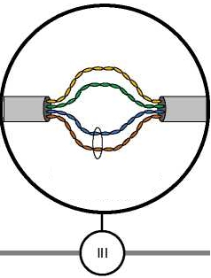

Pairs 4,5 and 7,8
Passive PoE

Figure 2.3 Power supply scheme over PoE in different cases

2.4 Optical port

The optical port of the switch is made in the form of a SFP slot, which operates at speeds of 100Mbps or 1000Mbps, depending on the position of the jumper FIBER.
Table 2.4. Compatibility of SFP modules
 | 100Base-X | 1000Base-X
Module 1.25Gbit/s | yes | yes
Module 155Mbit/s | yes | no
IMPORTANT! The switch is supplied without SFP module.

  - Lightning protection
The switch has in-built lightning protection modules that provide protection of Ethernet ports and power supply circuits 230VAC from common-mode and differential electromagnetic disturbances.
The switch is resistant to high-energy microsecond pulse interference according to GOST R 51317.4.5 standard with a degree of rigidity according to Table 2.5-1 with performance criteria B.
Switches are resistant to dynamic changes in the voltage of the AC electrical network in accordance with standard GOST R 51317.4.11 according to Table 2.5-2 with the performance criteria B.
Table 2.5-1.
Port | Degree of rigidity according to the table 1 GOST R 51317.4.5 | Voltage pulse value, kW + 10%
Power lines of the switch “wire-wire” | 3 | 2
Power lines of the switch “wire-ground” | 4 | 4
Symmetrical communication lines of the switch “wire-ground” | 3 | 2

Table 2.5-2.
Types of impacts | Degree of rigidity at testing | Test Voltage,% in,  + 5 % | Amplitude of dynamic voltage changes, % Ur | Duration of dynamic voltage changes, periods (ms)
Voltage dips | 1 | 70 | 30 | 10 (200)
Voltage interruptions | 1 | 0 to 20 | 100 | 1 (20)
Voltage  surge | 2 | 120 | 20 | 25 (500)
Note - Ur - rated supply voltage.

(Performance criterion B - temporary deterioration in the performance quality or termination of the established function with the subsequent restoration of normal functioning, carried out without the operator’s intervention) Maintainability is preserved during fluctuations in supply voltage from ~ 187 to ~ 253 V
  - Cold start
The most critical moment in the operation of the video camera is the process of its activation at low ambient temperature. Precisely a cold start can cause the failure of an expensive video camera. To avoid such cases, the switch is implemented with preheating of TFortis TH camera housings. The essence of it is that after power is applied to the unit, initially will be powered heating elements of camera housings, and only then in 1 hour the video camera itself. This delay allows obtaining comfortable conditions for starting video cameras and you will be able to save expensive equipment. This option is on by the TIMER jumper.
  - Restart of video cameras at their hanging
Switch constantly monitors the intensity of the traffic from the video camera. If the network activity is lost, the switch resets the camera by removing power through PoE. This feature is enabled by setting AUTO RESTART jumper to ON for a specific port.
- Technical parameters
Ports
- 100/1000Base-X with SFP connector - 1 pc.;
- 10/100Base-Tx with RJ-45 connector – 1 pcs;
- supports Auto-MDIX for the port 10/100Base-Tx;
- supports flow control of IEEE 802.3x;
- supports IEEE802.3af – 15.4 W at a port;
- supports Passive PoE – 15.4 W at a port;
- data and PoE transmission distance – up to 100m.
Power supply
- unit supply voltage – 230VAC (from 187V to 253V);
- max power consumption – 60W.
Design
- dimensions – 160х160х90 mm;
- Maximum weight - 1 kg;
- protection rating IP66;
- cable glands for cable
- diameter 4-8 mm – 2 pcs.
- diameter 6-12 mm – 1 pc.
Reliability
- mean time between failures is more than 75 000 hours (8,6 years);
- Operation conditions
The switch is intended for 24-hour outside operation at ambient temperature from -60C to 50C (using industrial SFP modules).
The switch maintains declared parameters at a storage temperature from -60C to +50C.
- Presetting
  - Configuring PoE on port
PoE power configuration is carried out using jumper (see section 2.3).
IMPORTANT! All connections must be made with the disconnected power 230VAC.
IMPORTANT! Remove the PoE jumpers for the port to which you will connect the computer.
  - Speed mode configuration for SFP port
SFP port of the switch can operate at the speed 100М or 1000М. To set the speed, set the FIBER jumper according to table 5-2
Table 5-2. Speed mode for SFP module
Operation mode | Location | Note
100Base-X | 100M
1000Base-X | 1000M | By default

IMPORTANT! Optical SFP module with the declared speed up to 1.25 Gb operates in 100M and 1000M modes. An optical SFP module with the declared speed up to 155MGb operates only in 100M mode.
  - Enabling Preheating of camera housings
When the camera is turned on in the cold, it may not start or, even worse, fail. To solve this problem, use the comfort start function. For this, you need to install jumper TIMER in the position ON. After the power is turned on, the preheating of the camera housing is switched on. Moreover, after 1 hour, when comfortable conditions will be created in the camera housing, a video camera will be powered. By default, this function is disabled.
IMPORTANT! This function is available only with TFortis TH camera housings.
- Device installation
  - Unit mounting
The enclosure has four attachment points along the edges of the unit. The marking of the fastening for the installation of the product is shown on the Fig. 6.1.
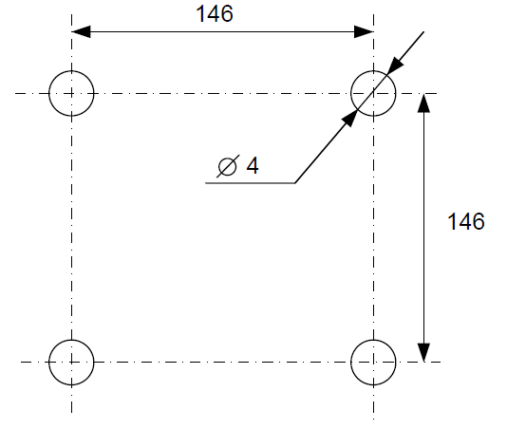
Figure 6.1. Marking of the fastening
IMPORTANT! Drilling of the housing leads to a violation of the sealing of the entire commutator and, as a consequence, the loss of warranty.
  - Optic connection
There are no elements for welding of the optical fiber inside the PSW-11. It is recommended to use External Optical Distribution Frames.
  - Power connection
PSW-11 is connected to an AC source of 230VAC. The supply cable is brought into the unit through the cable gland, where it is connected to the terminal block of the power supply unit.
IMPORTANT! Grounding of the device is required. The ground resistance must be no more than 4 Ohm.

IMPORTANT! Do not allow circuit boards touching high voltage live wires. Failure in this case entails a loss of product warranty.
IMPORTANT!
Since the switch contains switch-mode power supplies, it is a reactive load. During start-up, when charging input capacitors, a starting current appears and it exceeds the nominal value. In order to avoid false alarms of the protection devices, it is recommended to choose models with the characteristic C for a current of at least 4A.
  - Connection of video cameras
The camera is connected to the switch using a twisted pair. It is recommended to use a 4-pair shielded cable no worse than Category 5. When using the TFortis TH camera housings, data transfer, powering video camera and camera housing will be carried out by one cable, which eliminates the need to use additional power cables.

RJ-45 RJ-45
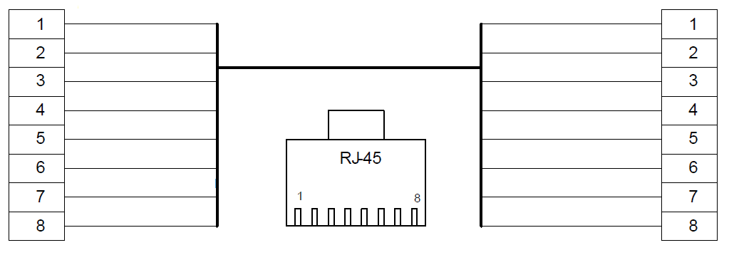
White Orange
Orange
White Green
Blue
White Blue
Brown
White Brown
Green
Brown
White Brown
Green
White Blue
Blue
White Green
Orange
White orange
Figure 6.4. Fanning out of the Ethernet cable.

- Manufacturer’s warranty
Warranty period for the device – 36 months from the sale date. The device is accepted for warranty maintenance and repair only in full completeness.
Warranty repair is not performed in following cases:
- if warranty period has expired;
- if there is no label with serial number on the product housing, and also if serial number was changed, removed or illegible;
- if there are external and internal mechanical damages (chips, cracks, deformation, damage to the power cord, breaks and cracks of connectors), traces of chemicals, corrosive environments, liquids, heavy contamination, as well as the presence of insects or traces of their presence;
- due to non-compliance with the rules of connection and operation, as well as non-compliance of power specified in the operating manual;
- due to force majeure, third party action and other reasons that doesn’t depend on manufacturer.

