Operating Manual

PSW-2G2F+UPS

Multifunction Gigabit Managed Switch

with built-in UPS for connection to IP video cameras that support IEEE802.3at.

Version 8

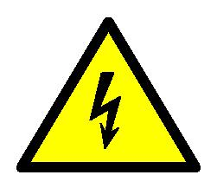

!

!

!

Elements of the power units are under high voltage. It is strictly forbidden to touch conducting elements of the power supply unit under voltage.

It is forbidden to transport the switch with the battery installed in it.

It is forbidden to connect very low battery (voltage at the terminals below 9.6V)

SFP port operates only at 1000 Mbps. Fast Ethernet SFP modules will not operate.

2

Contents

1. Purpose 4
2. Features………………………………………………………………………..5
3. Description 6

3.1. Appearance 6
3.2. Components layout 8
3.3. PoE power supply 9
3.4. Lightning protection 10
3.5. Restarting cameras in case of hanging 11
3.6. Cable tester 11

3.7. Remote camera polling 12
3.8. Built-in UPS 12
3.8.1. Control of incoming voltage 12
3.8.2. Description of UPS operation 13
3.8.3. Estimation of uninterrupted operation time 15
3.8.4. Battery function check 16
3.8.5. Battery installation 16

3.8.6. Control of fans operation 17
4. Technical parameters 18
5. Operating conditions 18
6. Preliminary setting 19
6.1. Resetting the switch to factory settings 19
6.2. IP address setting 19

6.3. User name and password setting 20
6.4. Activation of redundancy protocols 20
7. Installation of the switch 21
7.1. Mounting of the housing 21
7.1.1. Wall mounting 21
7.1.2. Mounting on the pole 21
7.1.3. Installation into TFortis CrossBox cabinet 21

7.2. Optical connections 23
7.3. Power supply connection 23
7.4. Camera connection 24
8. Manufacturer's warranty 25
9. Technical support…………………………………………………………..25

3

- Purpose

PSW-2G2F+UPS device is a multifunction gigabit outdoor managed switch with built-in UPS designed for connecting IP video cameras with IEEE802.3at (PoE+) support
- one camera with 60W power consumption (Figure 1-1)

- two cameras with 30W power consumption each (Figure 1-2)
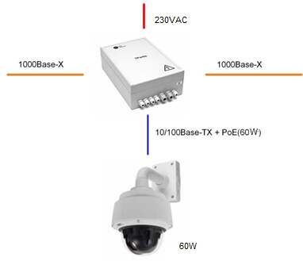

Figure 1-1. Connection scheme for one 60W camera.
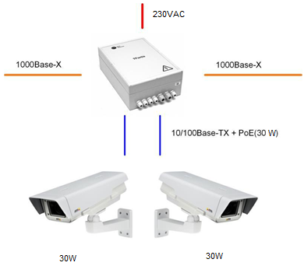

Figure 1-2. Connection scheme for two 30W cameras.

4

- Features
Weatherproof design

The switch body is made of technopolymer resistant to severe operating conditions. Dust and moisture protection rating is IP66. It is possible to operate the device without additional enclosures.

Operation is a wide temperature range

The device is manufactured from industrial-type components and does not need additional heating. The exceptions are batteries that are heating using two heaters, which ensures operation of the device in the range from - 45 to +40C.

High performance gigabit switch

The key element of the switch is high performance chip from Marvell, which is able to process a large volume of traffic coming from the IP cameras.

PoE+ support for one port up to 60W

The switch supports IEEE802.3at power supply. Power can be supplied either by pairs with data (pairs 1,2 and 3,6), or by free pairs (pairs 4,5 and 7,8) simultaneously. As a result, 60W can be supplied to the camera (30W+30W).

PoE+ support for two ports, 30W each

The switch can support operation of two ports with 30W power for each port.

Uninterrupted power supply for the whole system

Because the switch is equipped with UPS and cameras can be supplied by PoE, the whole system has power backup.

Withstands the voltage of 380V

When 380V voltage is supplied to the switch, it will be supplied from the battery and the whole system will continue to operate from the reserve power supply.

Connection to 230VAC

A built-in power supply unit ensures direct connection of the switch to 230VAC power supply, eliminating the need for additional power supply unit.

Lightning protection

A built-in lightning protection for Ethernet ports and 230VAC power supply protects the switch and connected cameras from surges caused by electrostatic discharges.

5

Automatic restart in case of camera hanging
The switch controls operation of the video camera. In case of hanging, the switch will restart the camera automatically over PoE. It allows to create unattended IP video surveillance networks.

Operation in a ring or in a chain configuration

Two gigabit ports allow to connect switches in a chain. Support of STP/RSTP protocols allow to create ring topologies, which significantly improves fault tolerance of the system.

- Description

3.1. Appearance
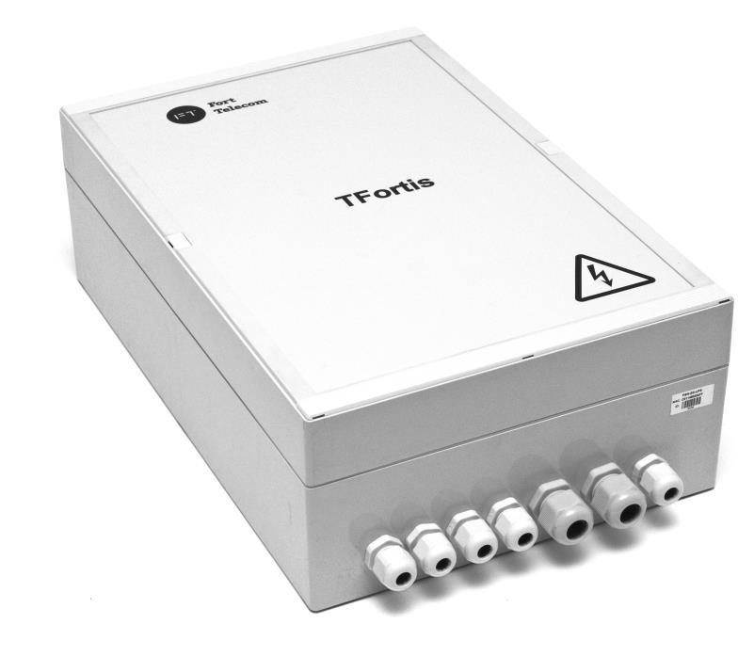

Figure 3.1-1. PSW-2G2F+UPS switch, external appearance

6

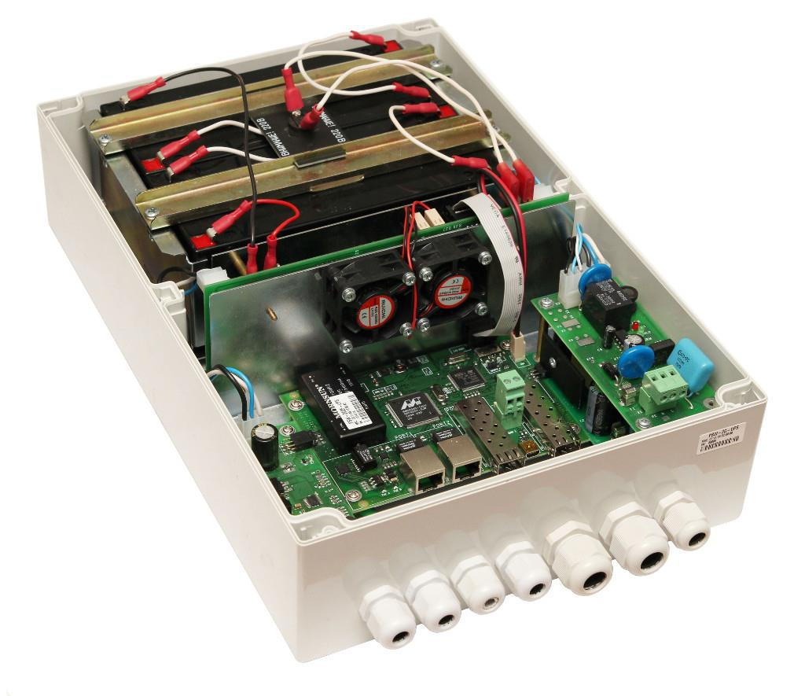

Figure 3.1-2. PSW-2G2F+UPS switch, interior view

7

3.2. Components layout

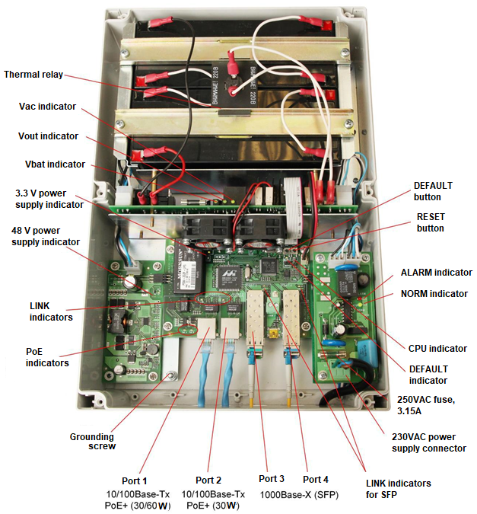

Figure 3.2-2. Layout of components in PSW-2G2F+UPS switch

During normal operation, CPU indicator should blink intermittently with 2 sec. period (1 sec. –ON, 1 sec. – OFF). DEFAULT indicator shall be ON, when the device operates with factory settings (IP 192.168.0.1).

8

3.3. PoE power supply

PSW-2G2F+UPS switch supports IEEE802.3at power supply. The switch can supply
- either one camera with 60W power consumption (by default)

- or two cameras with 30W power consumption each

Port 1 (60W)

Power is supplied by pairs 1,2 and 3,6 over data, and by free pairs 4,5 and 7,8 simultaneously. This way of power supply is implemented in powerful video cameras with power consumption up to 60W.
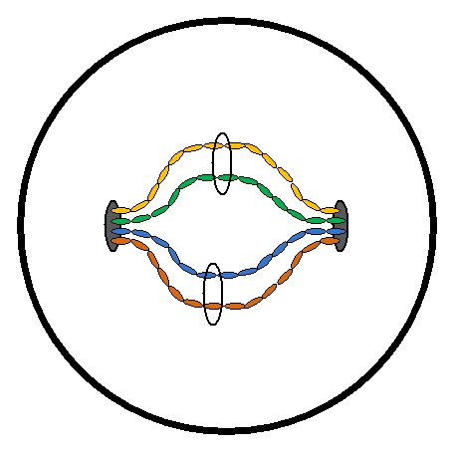

60 W |  |  |  |  |  | PSW-2G2F+UPS
 |  |  | Pairs 1,2 and 3,6
 |  |  | IEEE802.3at
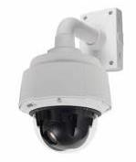
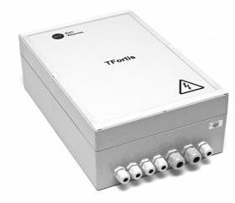

Pairs 4, 5 and 7, 8

IEEE802.3at

Figure 3.3-1. Power supply scheme over PoE+ (60W)

WARNING! For operation with BEWARD cameras that support UltraPoE, this mode has to be activated in the switch via WEB interface (see Configuration Manual).

Port 2 (30W)
Power is supplied via pairs 1, 2 and 3, 6 over data.
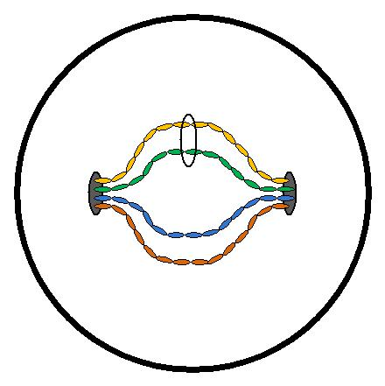

30 W |  |  |  |  |  | PSW-2G2F+UPS
 |  |  | Pairs 1,2 and 3,6
 |  |  | IEEE802.3at
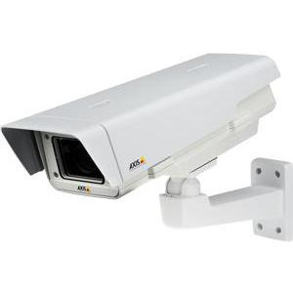

Figure 3.3-2. Power supply scheme over PoE+ (30W)

WARNING! First switch port 1 to 30W mode, then activate PoE on port 2 (see Configuration Manual).

9

3.4. Lightning protection

PSW-2G2F+UPS switch has built-in lightning protection modules that protect Ethernet ports and 230VAC power circuits from common-mode and differential electromagnetic interferences.

The switch is resistant to powerful microsecond pulse interferences according to GOST R 51317.4.5 standard with the degree of severity according to Table 3.4-1, performance criteria B.

The switch is resistant to AC transients in the power supply circuit according to GOST R 51317.4.11 standard, Table 3.4-2, performance criteria B.

Table 3.4-1.
port | Degree of severity according to Table 1 GOST R 51317.4.5 | Voltage pulse
 |  | value, kV + 10%
Power supply lines | 3 | 2
“wire-to-wire”
Power supply lines | 4 | 4
“wire-to-ground”
Symmetrical communication lines | 3 | 2
“wire-to-ground”

Table 3.4-2.

Type of impact |  | Degree of test severity |  | Test voltage,  % Un, + 5 % |  |  | Amplitude of dynamic voltage changes  % Un |  |  |  | Period of voltage changes (ms)
Voltage dips | 1 |  |  | 70 |  |  | 30 |  |  |  | 10 (200)
Voltage interruptions | 1 |  |  | 0 to 20 |  |  | 100 |  |  |  | 1 (20)
Voltage surges | 2 |  |  | 120 |  |  | 20 |  |  |  | 25 (500)
Note: Un is the nominal power supply voltage.

10

("Performance criteria B" means temporary disruption of performance or functioning with further recovery without operator's intervention) Continued operation with changes in the supply voltage from ~187 to ~253V

3.5. Restarting cameras in case of hanging

The switch continuously monitors camera operation.
There are two ways to detect camera hanging:

- Network activity falls down
- No response to service Ping requests
- Reduction of port speed below the established limit

Camera restart due to reduced network activity

The switch continuously monitors the intensity of traffic from the camera. If network activity is lost, the switch will restart the camera by disconnecting PoE power supply. "Auto Restart" option is available via WEB interface in the "Special Function" section.

Camera restart due to no response to Ping request

The switch constantly (1 time per minute) polls the IP camera. If the switch does not receive a response, then a one-minute timer is started,

- during this time the poll is repeated every 10 seconds. If the camera has not responded within a minute, the switch removes power from the camera for 10 seconds and supplies it again, restarting the camera. If the camera has responded at least once, the switch makes a decision that the camera is functional and starts the poll cycle again, polling the camera 1 time per minute. "Auto Restart" option is available via WEB interface in the "Special Function" section. To use this function, it is necessary to enter the IP address of the camera. Make sure your camera responds to PING

Camera restart in case of port speed reduction
The switch continuously monitors the speed on the port the camera is connected to. If the flow speed goes below the established limit and fails to restore, the switch makes a decision that the camera is hanging and reboots it. The user may specify the limit values (see the Configuration Manual).

11
3.6. Cable tester

The switch has the functions of a virtual cable tester (VCT), which allows to determine the breakage of the twisted pair, short-circuiting the wires of the twisted pair, unconnected cable to the camera, the distance from the switch to the fault. The cable tester diagnoses couples that transmit data (1, 2 and 3, 6). Note that the accuracy of the cable tester is ± 2 meters.

By default, VCT operates on an average algorithm and does not take into account the specific features of a particular cable, which can affect the accuracy of the measurement. To improve the accuracy of the cable tester, it is recommended to calibrate it. Note that calibration is not recommended for cables shorter than 10 meters.

3.7. Remote camera polling

Using the switch, it is possible to ping any device on the network through the WEB interface, which is convenient when solving network problems.

3.8. Built-in UPS

3.8.1. Control of incoming voltage

The switch monitors the input voltage. If the input voltage is above 260V or below 180, the switch is disconnected from the power supply and switches to battery power. This unit protects the device from

- phase unbalance
- loss of zero (380V)
- connection error (380V)

Table 3.8.1 – Indicators of the voltage monitoring relay Indicator Description

NORM | The switch is powered from the power supply
ALARM | Power supply voltage is not applied to the switch
 | due to increased or decreased voltage.

WARNING! When the power is turned on, the ALARM indicator always lights up. Only after 5-10 seconds the device goes into normal operation mode.

12

3.8.2. Description of UPS operation

The switch has a built-in UPS based on PSU, charge controller and battery (if included). The operation status is described by three indicators "VBAT", "VOUT" and "VAC".
Table 3.8.2-1 – UPS indicators
Indicator Description

VOUT Presence of an output voltage

VBAT Presence of a connected battery

VAC | Presence of an alternating current network

When supply voltage is present, the switch is powered and the battery is charging. Every 10 seconds the battery charge circuit is disconnected for 1 second and the voltage level at the battery terminals is checked. If the battery is not connected, or is not properly connected, or if the battery terminals are closed, the "VBAT" light diode is not lit.

When supply voltage is disconnected, the system automatically switches to battery backup power. "VAC" indicator goes off. In the backup mode, the voltage level at the battery terminals is monitored. When this voltage drops below 46V, "VBAT" indicator starts to flash intermittently with 2 sec. interval (1 sec. – ON, 1 sec. – OFF). In case of further voltage drop below 42V, "VBAT" indicator turns off and the switch goes into sleep mode to prevent deep battery discharge.

The switch has the function of delayed start. The operating principle is as follows. If battery terminals are connected in the absence of external supply voltage of 230VAC, the switch will not start. It will go into sleep mode and wait for the supply voltage to appear. In this state, the "VBAT" indicator flashes once every 10 seconds. This function allows to save the battery capacity before the start of the entire system. After 230VAC power is supplied, the batteries will go into the backup mode.

In practice, usually the entire system is initially assembled and only then, when everything is checked, 230 VAC power is supplied. Sometimes this process takes time. If there is no delayed start function, then after connecting the battery, the switch and cameras will start working immediately. Loads will gradually discharge the battery to a safe voltage. Deep discharge is prevented. However, a prolonged stay in a semi-discharged state

13

leads to a drop in battery capacity. To prevent this, delayed start function was implemented.

Table 3.8.2-2 – Indication of UPS state
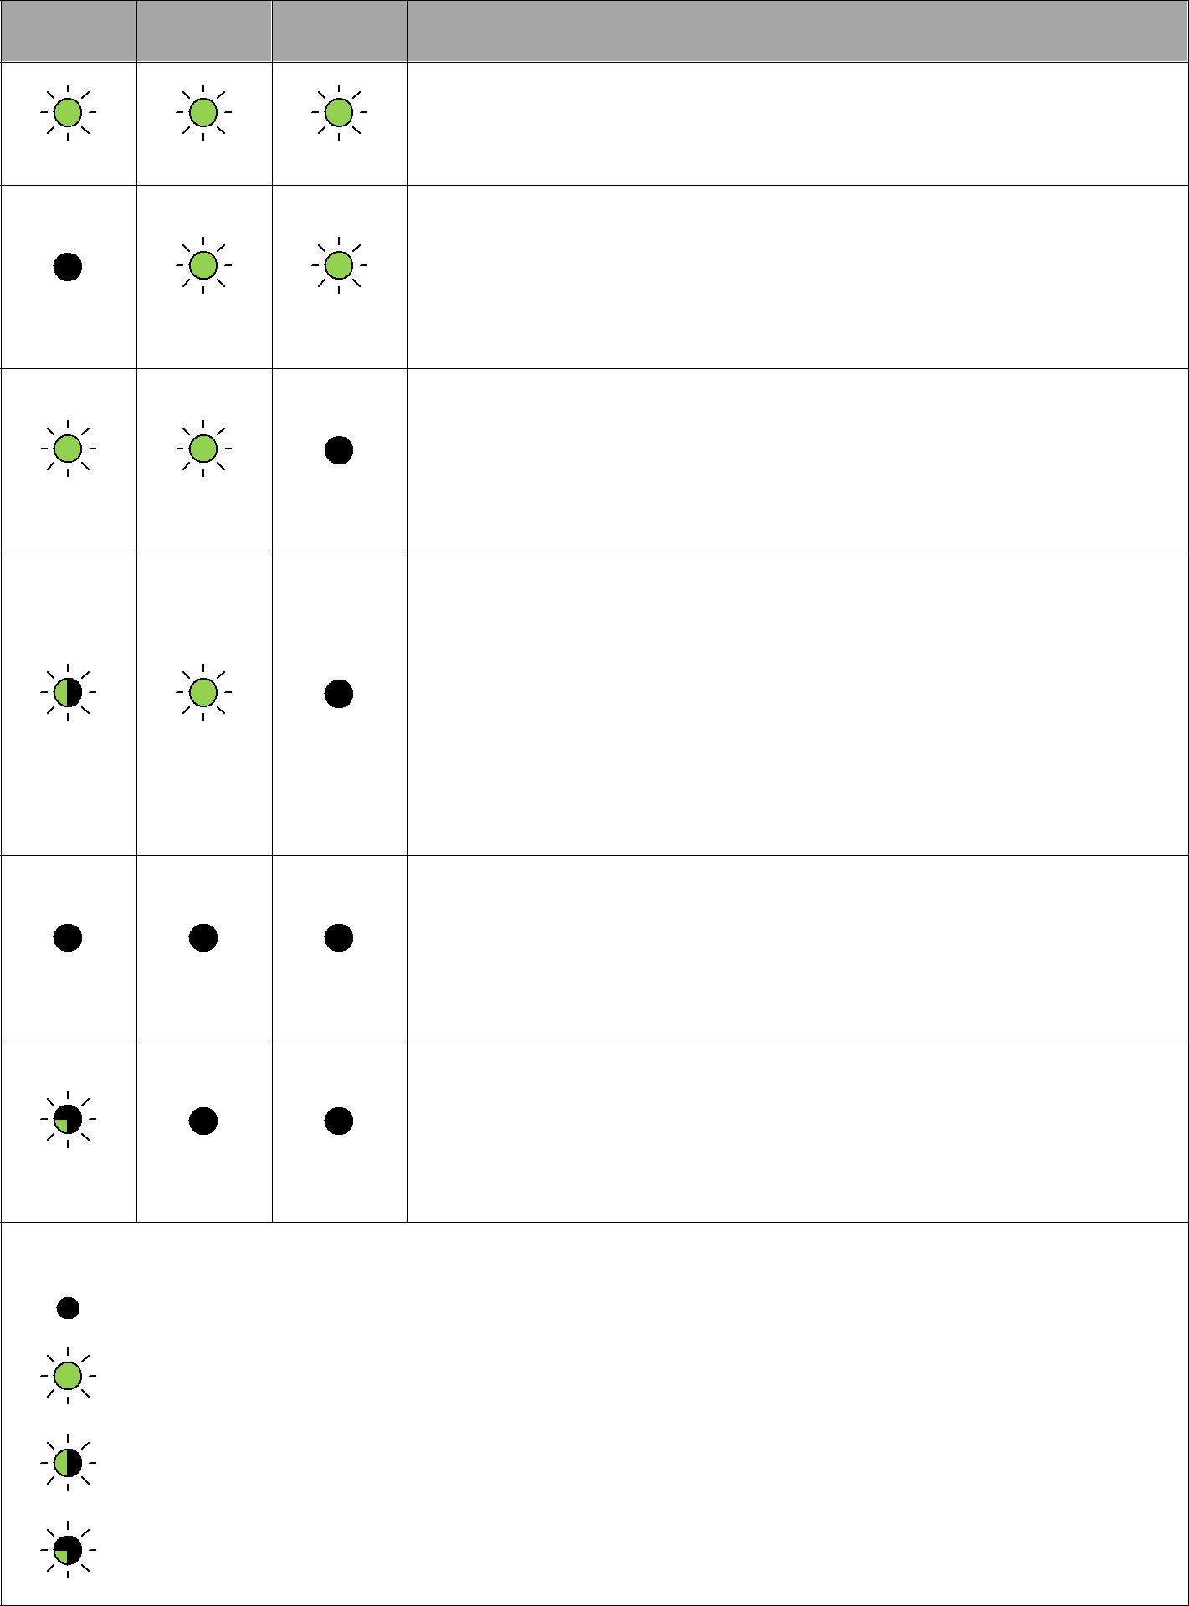
VBAT VOUT VAC | Description
 | The switch operates from the power grid, battery is present, the battery voltage is normal.
The switch operates from the power grid, battery failure (battery not connected, wrong
polarity or terminals are closed)

 | The switch operates from the battery (battery voltage is above 46V), supply voltage is absent.
The switch operates from the battery (battery voltage is below 46V, but above 42V), supply
voltage is absent. Blinking of VBAT light diode indicates, that the battery is low.
 | The switch is completely de-energized, or
 | is in sleep mode with discharged
 | battery.
 | The switch is in
 | delayed start mode and is expecting
 | the 230VAC supply.

where

indicator is OFF

indicator is ON

indicator is ON for 1 second and OFF for 1 second

indicator blinks 1 time in 10 seconds.

WARNING! It is forbidden to connect very low battery (voltage at the terminals below 9.6V)

14

3.8.3. Estimation of uninterrupted operation time

Uninterrupted operation time depends on the following factors: power consumption of the camera, ambient temperature, residual capacity of the battery. The most significant is the power consumption of the camera.

Table 3.8.3. Estimation of uninterrupted operation time
Load *, W | Time
0 | 7:10
5 | 5:40
10 | 4:10
15 | 3:10
20 | 2:30
25 | 2:10
30 | 1:50
35 | 1:40
40 | 1:30
45 | 1:10
50 | 1:00
55 | 0:55
60 | 0:50

- Load is the total power of the cameras + loss of power on the twisted cable

- In the camera documentation the manufacturer normally specifies the maximum power consumption with the IR illumination and heating ON.

Note that Table 3.8.3 shows the approximate battery life. These values are recommended for use during system design.

The switch constantly recalculates the remaining operation time from the battery based on the current power consumption. This information is available through the WEB interface.

15

3.8.4. Battery function check

Battery capacity is the amount of electricity given by a fully charged battery until it is discharged to reach the final voltage. Battery capacity changes throughout the service life. During operation, the capacity remains stable for a while, and then begins to gradually decrease (residual capacity).

Residual capacity can be estimated by special devices (battery capacity testers). It is recommended to estimate the battery condition once a year. Using a battery with a small residual capacity reduces the uninterrupted operation time of the switch. Switch batteries operate in the floating mode. The service life of the batteries supplied in this kit (if included) is 5 years under normal conditions. When the switch operates with frequent power outages or in hot climates, the battery wears more rapidly. If it is not possible to test the battery as described above, we recommend replacing the battery every 2 years.

3.8.5. Battery installation

Recommended battery models
- DTM12022 Delta

- DJW12-2.3 Leoch
- BP2.3-12 BB
- GP1222 CSB
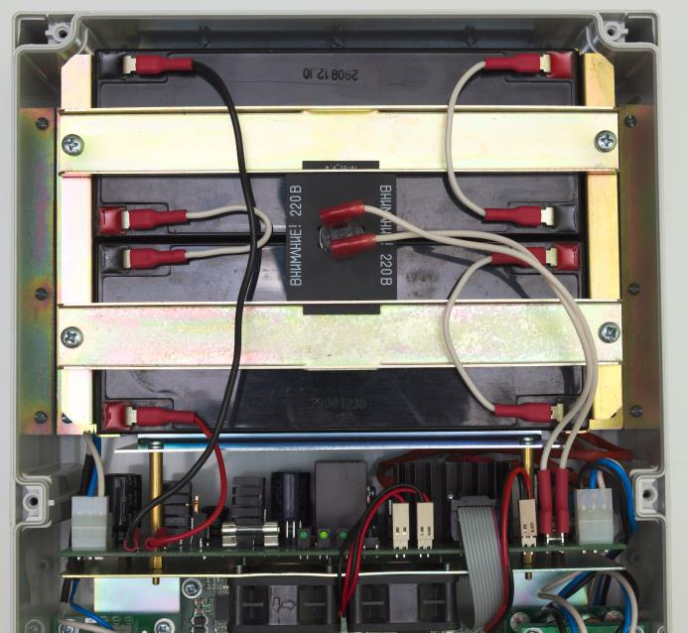

Figure 3.8.5. Connecting the battery.

16

Put the battery into the battery compartment, observe the polarity. Place a board with thermocouple between the batteries, fix the batteries with metal holders. The thermocouple should fit tightly against the battery housings. Connect the wires (Figure 3.8.5).

WARNING! During installation be careful not to short-circuit the battery terminals with holders.

WARNING! 230 VAC voltage is supplied to the thermocouple.

3.8.6. Control of fans operation

The switch is equipped with fans. They are switched on only in case of high temperature inside the unit. To check the functionality of fan control circuits, it is necessary to apply 230 VAC to the switch and press the control button (Figure 3.8.6). The fans should turn on. This check is recommended after installation of the switch in place.
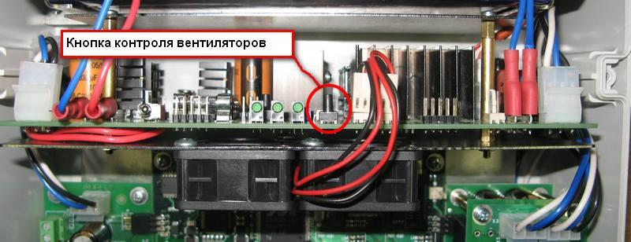

Figure 3.8.6. Checking functionality of the fans.

17

- Technical specifications

Gigabit Ethernet ports
- 1000Base-X with SFP connector;

- Number of ports – 2;
Fast Ethernet ports
- Port 1 10/100Base-Tx with PoE (60W);

- Port 2 10/100Base-Tx with PoE(30W);

- supports IEEE802.3at – 60W per port;

- supports Auto-MDIX for port 10/100Base-Tx;

- supports IEEE 802.3x flow control;

- PoE and data transfer distance – up to 100 m. Power supply
- PSU voltage 230VAC (187 to 253V);

- maximum power consumption 220W.

- battery characteristics

  - nominal voltage 12V;
  - capacity 2.2A * h;
  - dimensions 178*35*61 mm;
  - quantity – 4.

Design
- dimensions 240x360x120 mm;

- maximum weight 6 kg;

- environmental protection rating IP66;

- cable glands

  - diameter 4-8 mm – 5.
  - diameter 6-12 mm – 2.
Reliability
  - meantime between failures at least 75 000 hours (8,6 years).

- Operating conditions

PSW-2G2F+UPS switch is designed for 24-hour operation in outdoor conditions at an ambient temperature from minus 45 to plus 40 °C when used industrial SFP modules.

It is recommended to install the switch in places protected from direct sunlight (for example, under canopies, on the shady side of buildings)
Note 5.1.

The switch remains fully functional at storage temperatures from minus 55°C to plus 50°C.

Note 5.2.
Observe the storage conditions of the battery.

18

- Presetting

WARNING! Remove PoE jumpers for the port to which a computer will be connected.

6.1. Resetting the switch to factory settings

Before start, set the switch to the default settings. To do this, press and hold the DEFAULT button until the DEFAULT indicator lights up. The default IP address of the switch is 192.168.0.1.

6.2. IP address setting

All software functions of the switch can be managed, configured and monitored using the built-in Web interface and Telnet. Below is the description of WEB-based configuration. Configuration via Telnet is described in a separate document.

The switch can be managed from remote stations at any point of the network via a standard Web browser (for example, Microsoft Internet Explorer). The browser is a universal access tool and can directly access the switch using the HTTP protocol.

Connect any switch port to an Ethernet network. Keep in mind,

if the device is configured over a network, the IP address of the management work station should belong to the same IP network. For example, if the default IP address of the switch is 192.168.0.1, then the IP address of the work station should be 192.168.0.x (where x is the number from 2 to 254), subnetwork mask is 255.255.255.0 by default.

Open the Web browser and enter the IP address http://192.168.0.1.
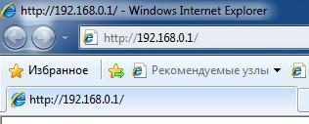

Figure 6.2. Entering the IP address of the switch

19

6.3. User name and password setting

While the "username" and "password" are not set, you will log in without entering this data. After the password is set, you will need to authenticate when you log in.
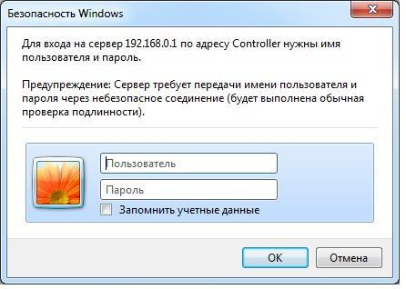

Figure 6.3. Entering user name and password.

Note, that the user name and password are case sensitive.

6.4. Activation of redundancy protocols

If you connect the switches into a ring, then you need to enable the RSTP protocol. Otherwise, if there are alternative paths, your network will not be functional. By default, RSTP is turned off.

20

- Mounting the device

7.1. Mounting of the housing

7.1.1. Wall mounting

The housing has four attachment points at the edges. Marking of the attachment points is shown in Figure 7.1.1.

226
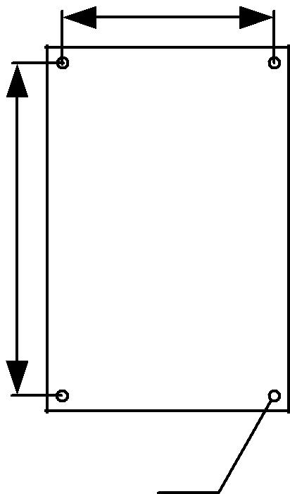

346

PSW-2G2F+UPS

4

Figure 7.1.1. Attachment points marking

WARNING! Drilling of the housing will lead of loss of the switch integrity and, as a result, loss of product warranty.

7.1.2. Mounting on the pole

To install PSW-2G2F+UPS switch on the pole, use TFortis mounting panel.

7.1.3. Installation into TFortis CrossBox cabinet

TFortis PSW-2G2F+UPS switch has a sealed enclosure from technopolymer with protection rating IP66. This is enough

21

to install the device outdoors. However, it is recommended that switches be placed in cabinets, because they can accommodate additional equipment (optical distribution frame, circuit breakers and other user equipment). In addition, the external metal cabinet has anti-vandal resistance.

For TFortis PSW switches, we recommend using TFortis CrossBox cabinets with IP54 protection. These cabinets already have a built-in optical distribution frame and DIN rail for circuit breakers.
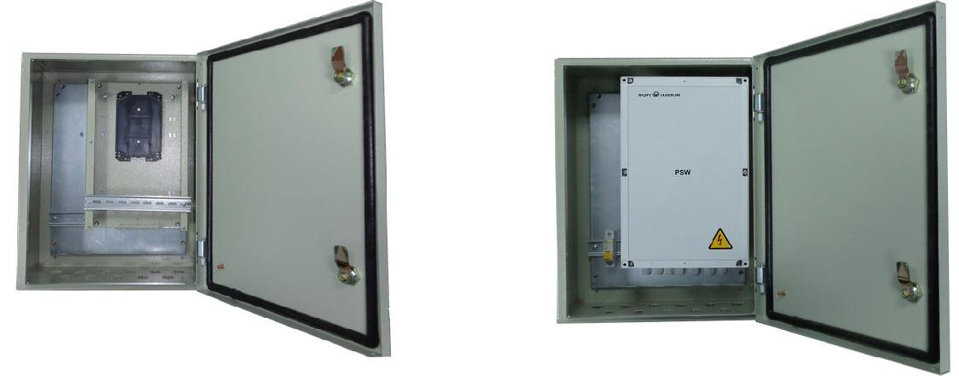

Figure 7.1.3-1. TFortis CrossBox-2 cabinet with PSW-2G2F+UPS switch

TFortis CrossBox cabinet is purchased separately. Note that TFortis CrossBox is recommended, but not mandatory.

To install the cabinet on the pole it is recommended to use a bracket. TFortis bracket is a universal fixture for mounting TFortis cabinets and camera housings on the poles (supports, towers). The fixture is a metal molded plate 3 mm thick. The bracket is attached to the pole by means of a bandage tape. The bracket mounted on the pole is permanently in

spring-loaded condition. This allows to withstand significant load without slacking.
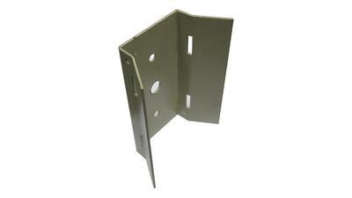

Figure 7.1.3-2. TFortis bracket

22

7.2. Optical connections

Inside PSW-2G2F+UPS switch there are no elements for welding optical fiber. It is recommended to use external optical distribution frames.

7.3. Power supply connection

The switch is connected to 230VAC source. Power supply cable is pulled into the unit trough a cable gland and is connected to the power supply terminal block (Figure 7.3-1).
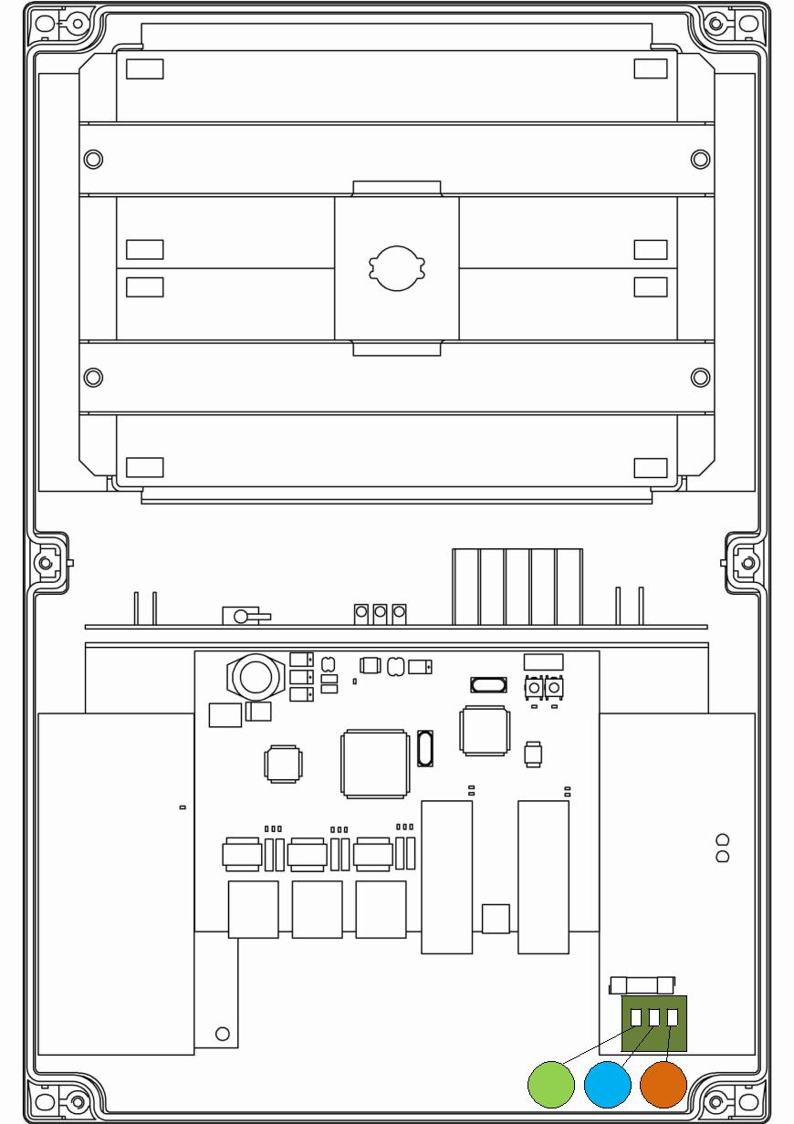

PE N L

Figure 7.3-1. Connecting power to PSW-2G2F+UPS.

23

WARNING! Grounding of the switch is obligatory. Grounding resistant should not exceed 4 Ohm.

WARNING! Energized high-voltage conductors should in no case be in contact with circuit boards. The resulting failure will lead to loss of product warranty.

WARNING!

The switch contains static power supply units and, therefore, is a reactive load. Inrush current that occurs during charging of the input capacitors will exceed nominal current values. To prevent false tripping of the circuit breakers, it is recommended to choose models with characteristic C for at least 4A current.

7.4. Camera connection

- Camera is connected to port 1 using a twisted pair. It is recommended to use a 4-pair shielded cable, at least category 5.

RJ-45 |  |  |  | RJ-45
 | white and orange |  |  | white and orange
1 |  |  |  | 1
 | orange |  |  | orange
2 |  | UTP / FTP |  | 2
 | white and green |  |  | white and green
3 |  |  |  | 3
 | blue |  |  | blue
4 |  |  |  | 4
 | white and blue |  |  | white and blue
5 |  |  |  | 5
 | green | RJ-45 |  | green
6 |  |  |  | 6
 | white and brown |  |  | white and brown
7 |  | 1 | 8 | 7
 | brown |  |  | brown
8 |  |  |  | 8

Figure 7.4. Separating the twisted pair.

24

- Manufacturer warranty

The warranty period for the switch is 36 months from the date of sale, except for the battery. The warranty period for the battery (if included) is 12 months. Only a complete switch is accepted for servicing and repair.
Warranty shall not apply in the following cases:
- if the warranty period has expired;

- if manufacturer's marking with the serial number on the housing is missing or if the serial number has been changed, removed or is illegible;

- if there are internal of external mechanical damages (chipping, cracking, deformation, damaged power supply wires, cracking or splitting of the terminals), signs of treatment with aggressive chemicals or fluids, severe contamination, insects presence or signs of insects presence;

- in case of improper connection and operation of the switch or if power supply parameters do not meet the requirements specified in the operating manual;

- if the switch was damaged as a result of force majeure, due to the actions of third parties or other reasons beyond manufacturer's control.

9 Technical support
To get technical support for the design of video surveillance systems, operation and adjustment of equipment:
Email at tfortis@fort-telecom.ru

All technical documents are available at: https://tfortis.com/support/dokumentaciya-na-produkciyu/

25

