

Operation Manual

PSW-2G4F

PSW-2G4F-UPS

Multifunctional Gigabit Managed Switch for IP- video surveillance systems

Version 9

|  |  |
| --- | --- |
| E:\Временные файлы\sdf.jpg | **Components of power supply units are under high voltage. Touching conducting components of active power supply units is forbidden.** |
| C:\Users\9E0A~1\AppData\Local\Temp\FineReader12.00\media\image2.jpeg | **When connecting the computer to the switch, remove PoE jumpers at this port.** |
| C:\Users\9E0A~1\AppData\Local\Temp\FineReader12.00\media\image2.jpeg | **Transportation of the switch with installed battery is forbidden.** |
| C:\Users\9E0A~1\AppData\Local\Temp\FineReader12.00\media\image2.jpegC:\Users\9E0A~1\AppData\Local\Temp\FineReader12.00\media\image2.jpeg | **It is forbidden to connect over discharged batteries (voltage at terminals is lower than 9.6V)**  **SFP module operates only at 1000 Mbps. Fast Ethernet SFP modules will not operate.** |
| C:\Users\9E0A~1\AppData\Local\Temp\FineReader12.00\media\image2.jpeg | **For effective operation of lightning protection is required:**   * **high quality grounding according to the ELC;** * **use of shielded twisted pair with shielded connectors RJ45;** * **minimization of twisted pair and power cable length;** |

**Modifications**

* PSW-2G4F
* PSW-2G4F-UPS (with built-in uninterruptible power supply)

Note.

The text describes the PSW-2G4F, the distinctive features of the PSW-2G4F-UPS are specified separately.

Table of Contents

Table of Contents 3

1. Designation 4

2. Features………………………………………………………………………………………..4

3. Description 6

3.1. Appearance 6

3.2. Element arrangement 8

3.3. Power Supply over PoE 10

3.4. 230VAC power supply backup…..……………….....…………………………..12

3.5. Tamper sensor 12

3.6. Lightning protection 12

3.7. Additional functions 14

3.7.1. Cold start 14

3.7.2. Restart of video cameras at their hanging 14

3.8. Diagnostic functions 15

3.8.1. Cable tester 15

3.8.2. Remote polling of video cameras 15

3.9. Built in UPS (PSW-2G4F-UPS) 15

3.9.1. Input voltage monitoring 15

3.9.2. Description of the UPS operation 15

3.9.3. Estimating the time of uninterrupted operation 18

3.9.4. Determination of battery performance 18

3.9.5. Battery installation 19

3.9.6. Monitoring the fan operation 20

4. Technical parameters 21

5. Operation conditions 22

6. Presetting 22

6.1. Restore switch to Factory Settings 22

6.2. Setting the IP address 22

6.3. Setting Up a user name and password 23

6.4. Configuring PoE on ports…………………………………………………………..23

6.5. Enabling Preheating of camera housings 24

6.6. Enabling backup protocols 24

6.7. Backup power supply configuration……………………………………………….24

7. Device installation 25

7.1. Unit mounting 25

7.1.1. Installation of the unit on the wall 25

7.1.2. Installation of the unit on the support 25

7.1.3. Installation of the unit into TFortis-CrossBox cabinet 26

7.2. Optic connection 27

7.3. Power connection 27

7.4. Connection of video cameras 30

8. Manufacturer’s warranty 30

9. Technical support 31

Appendix 31

1. Designation

Device PSW-2G4F is an Outdoor Multifunction Gigabit Managed Switch designed for networking of IP- video surveillance systems.

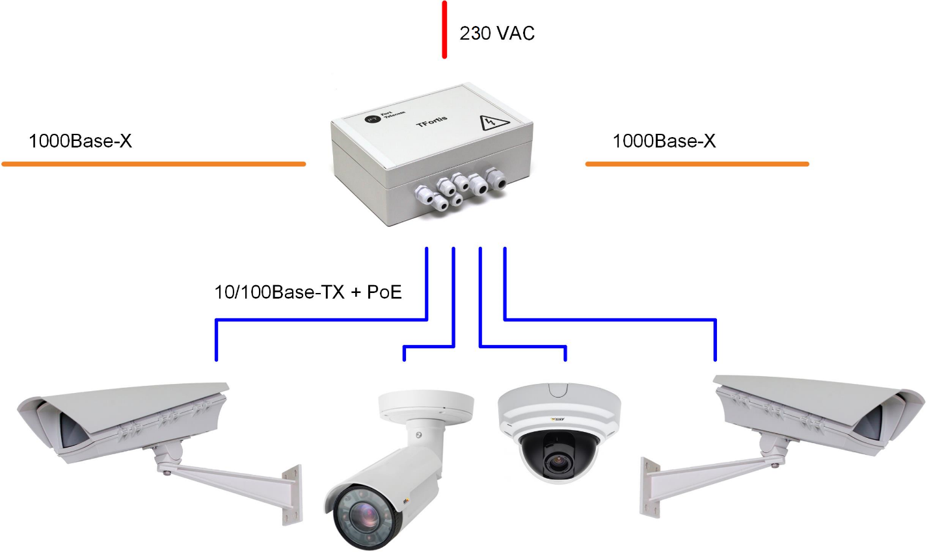Figure 1. Connection scheme for the PSW-2G4F

**2. Features**

**Weatherproof version**

The body of the device is made of a techno-polymer that is resistant to Stringent Operating Conditions. There is a protection from moisture and dust IP66.

**Operation in extreme temperatures**

The device has industrial hardware components that are characterized by an extended temperature range. Using industrial SFP modules in industrial version guarantees operation from -55°C to 50°C* and above (-67 to 122 F)*, up to +65°C with less load.

*The maximum temperature depends on the load (see diagram in section 5. Operation conditions)

**High- performance Gigabit Switch**

The basis of the switch is a high-performance chip from Marvell, which provides processing of a large traffic coming from IР-video cameras.

PoE Support

The switch can power any PoE-camera that supports IEEE802.3af standard.

**Power supply for camera housings over PoE**

Switch operating with TFortis TH camera housings powers both video camera (IEEE802.3af) and Camera Housing (Passive PoE) via twisted pair.

**Connection to 230VAC**

Built-in PSU provides direct connection of the switch to the Power Supply 230VAC and excludes need in additional PSU.

**Lightning protection**

Built-in Lightning protection of Ethernet ports and 230VAC PSU reliably protects both the switch and connected video cameras from pulse disturbances induced by lightning discharges.

**Cold start**

Preheating of camera housing provides safe and guaranteed turn-on of video cameras in cold conditions.

**Automatic restart of video cameras at their hanging**

The switch controls operation of video cameras. If video camera is hanging, switch restart it automatically over PoE. This allows constructing unattended IP- video surveillance systems.

**Operation in a ring and in a chain**

With two gigabit ports, you can connect the switches in chain. STP/RSTP protocol support allows creating ring topologies, what significantly increases the fault tolerance of the system.

**Uninterruptable power supply for the whole system**

Since the switch PSW-2G4F-UPS has an uninterruptible power supply unit and cameras operate via PoE, the whole system is reserved for power.

**Resistance to the voltage 380V**

When 380V is applied, the switch PSW-2G4F-UPS will switch to the battery and keep the entire system working from the backup power source.

**3. Description**

***3.1. Appearance***

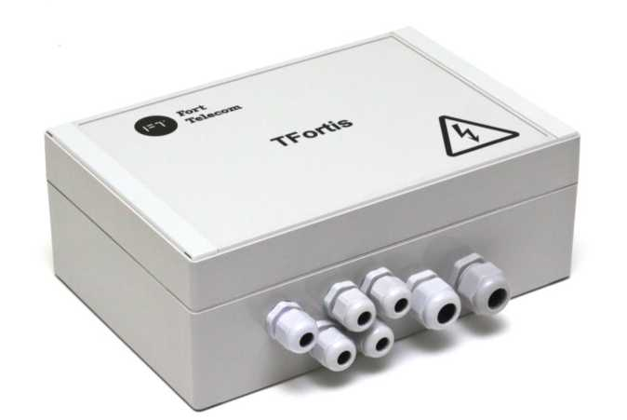

Figure 3.1-1. PSW-2G4F outside view

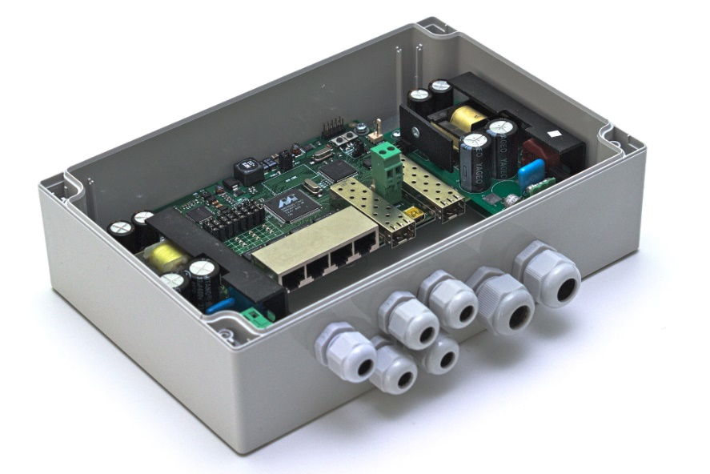

Figure 3.1-2. PSW-2G4F inside view

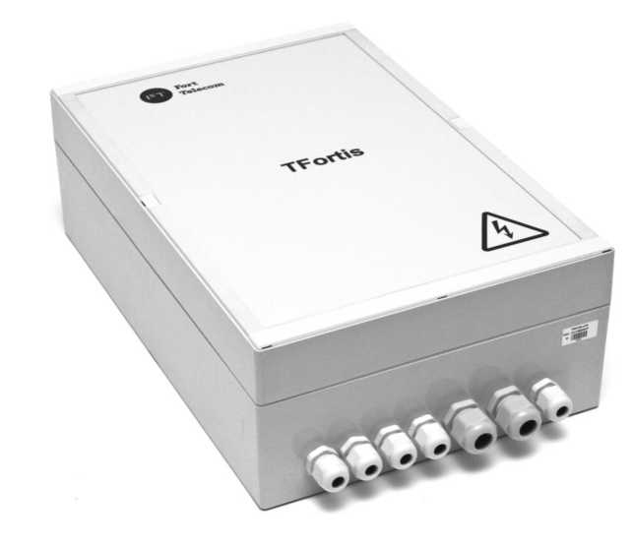

Figure 3.1-3. PSW-2G4F-UPS outside view

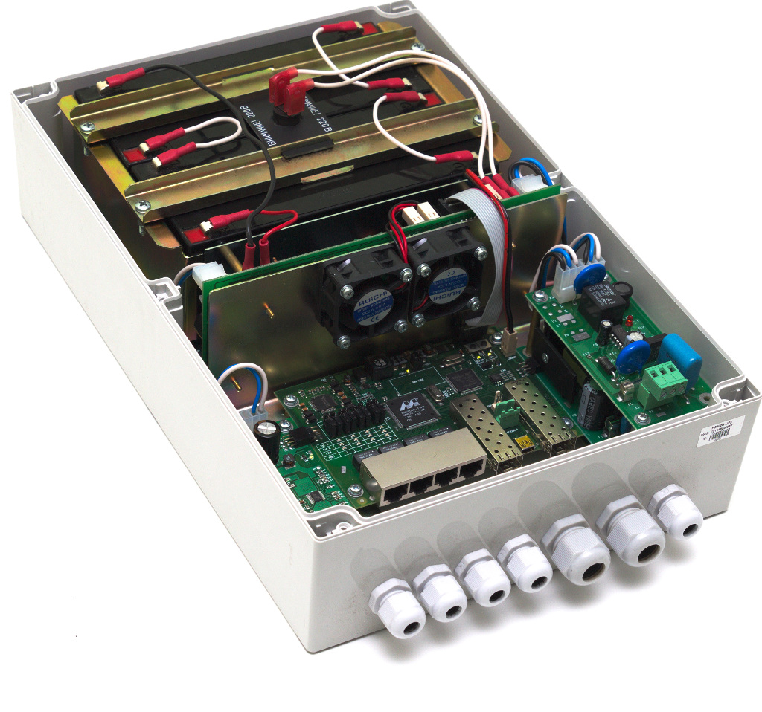

Figure 3.1-4. PSW-2G4F-UPS inside view

**2.2.Element arrangement**

Figure 3.2-1. Element arrangement of the PSW-2G4F

During normal operation of the processor, a CPU indicator must light intermittently with a frequency of 2s. (1 sec. - on, 1 sec. - off.) DEFAULT Indicator is on, when the device is in factory settings (IP 192.168.0.1).

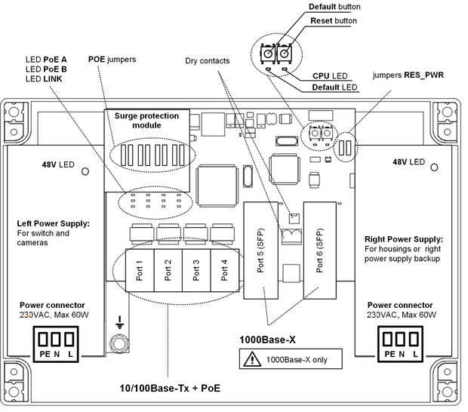

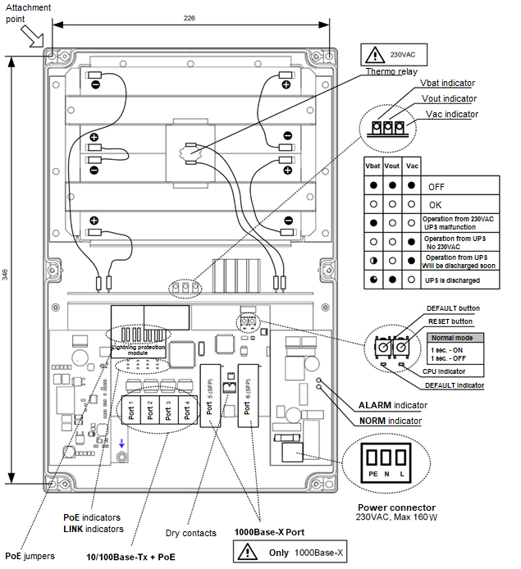

Figure 3.2-2. Element arrangement of the PSW -2G4F-UPS

* 1. Power Supply over PoE

The switch PSW-2G4F maintains power supply through IEEE802.3af and Passive PoE technology. Power supply is selected according to jumper configurations (Table 3-3). Power is supplied through pairs 1,2 and 3,6 over data or through free pairs 4,5 and 7,8. In the PoE standard terminology, first one is named as mode A and the second - mode B. Power is supplied to video cameras installed into TFortis TH camera housing using mode A and mode B simultaneously (I). When you connect other devices (not PoE), remove jumpers for relevant port (IV).

Table 3-3. Configuration of PoE jumpers

|  |  |  |  |
| --- | --- | --- | --- |
|  | Pairs 1,2 and 3,6 | Pairs 4,5 and 7,8 | Figure |
|  | IEEE802.3af  (video camera) | Passive PoE  (TFortis TH camera housings) | I |
|  | IEEE802.3af  (video camera) | - | II |
|  | - | IEEE802.3af  (video camera) | III |
|  | - | - | IV |

**IMPORTANT!** There are two power units in the switch PSW-2G4F. Left one supplies power to the video cameras and right one to camera housings. Make sure that total consumption of video cameras does not exceed 50W. If TFortis TH camera housings are not used, right PSU can be disconnected. Also, right PSU can be used as left PSU backup (see 3.4 section)

Figure 3.3 Power supply scheme over PoE in different cases 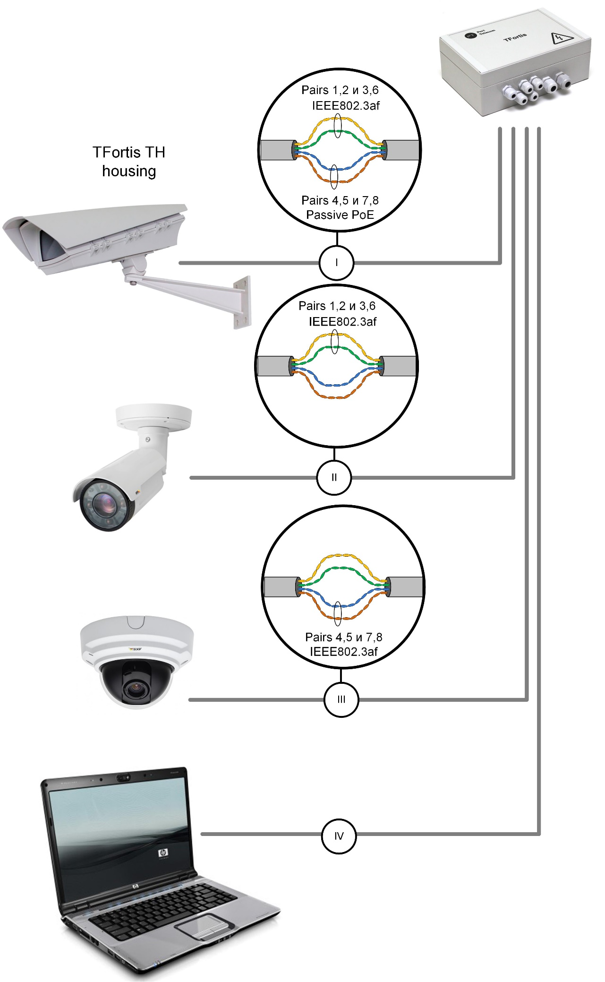

* 1. 230VAC power supply backup

There are two power supply units in PSW-2G4F switch. Left PSU is designed to power the switch and the camera housing over PoE. Right PSU has two operation modes, which are selected by RES_PWR jumper according to 3.4 table.

Table 3.4.

|  |  |  |  |
| --- | --- | --- | --- |
|  | Right PSU operation mode | RES_PWR | Note |
| 1 | TFortis TH camera housings power supply | NO | Default |
| 2 | Left PSU backup | YES |  |

* 1. Tamper sensor

On the switch board, there are contacts for connecting tamper sensor. When the magnetically operated sealed contact is connected, the normal state of the contact is normally closed, the alarm state is open. For end switches - all the way around. The state of “normally closed” or “normally open” is set via the WEB interface.

* 1. Lightning protection

The switch PSW-2G4F has in-built lightning protection modules that provide protection of Ethernet ports and power supply circuits 230VAC from common-mode and differential electromagnetic disturbances.

Switches are resistant to high-energy microsecond pulse interference according to GOST R 51317.4.5 standard with a degree of rigidity according to Table 3.6-1 with performance criteria B.

Switches are resistant to dynamic changes in the voltage of the AC electrical network in accordance with GOST R 51317.4.11 standard according to Table 3.6-2 with the performance criteria B.

Table 3.6-1.

|  |  |  |
| --- | --- | --- |
| Port | Degree of rigidity according to the table 1 of standard GOST R 51317.4.5 | Voltage pulse value, kW + 10% |
| Power lines of the switch “wire-wire” | 3 | 2 |
| Power lines of the switch “wire-ground” | 4 | 4 |
| Symmetrical communication lines of the switch “wire-ground” | 3 | 2 |

Table 3.6-2.

|  |  |  |  |  |
| --- | --- | --- | --- | --- |
| Types of impacts | Degree of rigidity at testing | Test voltage, % in, + 5 % | Amplitude of dynamic voltage changes, % Ur | Duration of dynamic voltage changes, periods (ms) |
| Voltage dips | 1 | 70 | 30 | 10 (200) |
| Voltage interruptions | 1 | 0 to 20 | 100 | 1 (20) |
| Voltage surge | 2 | 120 | 20 | 25 (500) |
| Note - Ur - rated supply voltage. | | | | |

(Performance criterion B - temporary deterioration in the performance quality or termination of the established function with the subsequent restoration of normal functioning, carried out without the operator’s intervention) Maintainability is preserved during fluctuations in supply voltage from ~ 187 to ~ 253 V

* 1. Additional functions
     1. Cold start

The most critical moment in the operation of the video camera is the process of its activation at low ambient temperature. Precisely a cold start can cause the failure of an expensive video camera. To avoid such cases, unit PSW-2G4F is implemented with preheating of camera housings TFortis TH. The essence of it is that after power is applied to the unit, initially will be powered heating elements of camera housings, and only then in 1 hour, the video camera itself. This delay allows obtaining comfortable conditions for starting video cameras and you will be able to save expensive equipment. Option Comfort Start is available via WEB-interface in the section Special Function.

* + 1. Restart of video cameras at their hanging

The PSW-2G4F constantly monitors the connection of the video camera to the switch. There are three ways to determine the camera’s hanging:

1. No connection to the video camera (Link)
2. No response to service requests (Ping)
3. Reducing the flow from the camera (Speed)

**Restart of the video camera over the Link signal.**

The PSW-2G4F switch constantly (1 time per minute) monitors the Link signal from the IP camera. If the switch does not detect the Link signal, then it starts a one-minute timer, when it ends, the connection is reconnected. If the Link signal does not appear, the PSW-2G4F removes power for 10 seconds and resets it, rebooting the camera. This mechanism can be described in other words. If the switch has not seen the Link signal from the video camera twice in a row with a 1-minute interval, then it reboots it. Option Auto Restart is available via WEB-interface in the section Special Function.

**Restart the video camera when there is no response to Ping.**

The PSW-2G4F switch constantly (1 time per minute) polls the IP camera. If the switch does not receive a response, then starts a one-minute timer, during which the poll is repeated every 10 seconds. If the video camera does not response within a minute, the PSW-2G4F removes power for 10 seconds and resets it, rebooting the camera. If the camera has responded at least once, the switch decides that the camera is functioning properly and will start the poll cycle once again, referring to the camera 1 time per minute. Option Auto Restart is available via WEB-interface in the section Special Function. To use this mechanism, you will need to enter the IP address of your video camera. Make sure your video camera is responding to the PING (see diagnostic functions section).

Video camera restart when reducing the flow from the camera

The PSW-2G4F switch constantly controls traffic level (intensity) from the camera. If the activity falls below the set level the switch restarts the camera by removing power from the PoE. This function is enabled via WEB interface for a specific port.

* 1. Diagnostic functions
     1. Cable tester

The PSW-2G4F has functions of a virtual cable tester (VCT - Virtual Cable Tester), which allows you to determine the break of the twisted pair, short-circuited twisted pair wires, unconnected cable to the video camera, distance between the defect and the switch. A cable tester diagnoses pairs that transmit data (1, 2 и 3, 6). Please note that the accuracy of the cable tester is ±2 meters.

By default, VCT operates on an average algorithm and does not take into account the specific features of a particular cable, which can affect the accuracy of the measurement. To improve the accuracy of the cable tester, it is recommended to calibrate it. Note that calibration is not recommended for cables with a length of less than 10 meters. See detailed information in 7.7.2.

* + 1. Remote polling of video cameras

With the PSW-2G4F it is possible to ping any device in the network via the WEB-interface, which is convenient when solving network problems.

* 1. Built in UPS (PSW-2G4F-UPS)
     1. Input voltage monitoring

The PSW-2G4F-UPS switch monitors input voltage. If the input voltage is above 260V or below 180V, the switch disconnects from the power supply and switches to the battery power.

This node protects the device from such phenomena as:

1. electrical imbalance
2. zero loss (380V)
3. connection error (380V)

|  |  |
| --- | --- |
| Table 3.9.1- Indicators of voltage control relay | |
| Indicator | Description |
| NORM | Switch is powered by mains voltage |
| ALARM | Mains voltage is not supplied to the switch due to high or low voltage. |

ATTENTION! When the power is turned on, the ALARM indicator always lights up. And only after 5-10 seconds the device goes into normal operation mode.

* + 1. Description of the UPS operation

The PSW-2G-UPS switch has a built-in uninterruptible power supply, implemented in the PSU, charge control unit and the battery (if included). Three indicators VBAT, VOUT and VAC. describe the operation status.

Table 3.9-2 - uninterruptible power supply unit indicators

|  |  |
| --- | --- |
| Indicator | Description |
| VOUT | Presence of the output voltage |
| VBAT | Presence of the connected battery |
| VAC | Presence of the AC network |

If there is a mains voltage, the switch is powered and the battery is charging. Every 10 seconds the battery charge circuit is disconnected for 1 second and the voltage level at the battery terminals is checked. If the battery is not connected or not properly connected, or if the battery terminals are closed, the VBAT LED is off.

When the mains voltage is disconnected, then power is supplied an automatically from the backup battery. The indicator VAC goes out. In the standby mode, the voltage level at the battery terminals is monitored. When this voltage drops below 46V, the VBAT indicator starts to flash intermittently at intervals of 2 seconds. (1 sec. on, 1 sec - off). With a further voltage drop below 42V, the VBAT indicator starts to flash intermittently at intervals of 4 seconds. (1 sec. on, 3 sec - off), and the switch is turned off, preventing deep battery discharge.

The switch has a deferred activation mechanism. Operating principle is as follows. If you connect the battery terminals in the absence of an external 230VAC mains voltage, the switch will not work. It will go into sleep mode and wait for the mains voltage to appear. In this state, the indicator VBAT flashes once every 10 seconds. This mechanism allows you to save the battery capacity before the start of the entire system. When 230VAC is supplied, the batteries will go into the standby mode.

In practice, at first, the whole system is assembled and only then, when everything is checked, the 230VAC power is supplied. Sometimes this process is stretched. If there is no delayed start mechanism, then after connecting the battery, the switch and video cameras will start working immediately. Consumers gradually discharge the battery to a safe voltage. Deep discharge is excluded. However, a prolonged stay in a semi-discharged state results in a drop in the battery capacity. To prevent this phenomenon, the deferred activation mechanism was implemented.

|  |  |  |  |
| --- | --- | --- | --- |
| Table 3.9-3 - state indication of the uninterruptible power supply unit | | | |
| VBAT | VOUT | VAC | Description |
|  |  |  | The switch is powered by the network, battery is present, voltage at the battery is normal. |
|  |  |  | The switch is powered by the network, battery failure (battery is not connected, polarity is not correct or terminals are closed) |
|  |  |  | The switch is powered by the battery (voltage at the battery is higher than 46V), mains voltage is absent. |
|  |  |  | The switch is powered by the battery (voltage at the battery is lower than 46V but higher than 42V), mains voltage is absent. VBAT LED flashing indicates that battery will soon be discharged. |
|  |  |  | The switch is completely de-powered or is in a sleep mode with discharged batteries. |
|  |  |  | The switch is in the waiting mode and waits supply of 230VAC mains voltage. |
| where  indicator is not lightning  indicator is lightning >V  indicator 1 s - on, 1 s - not lightning  indicator flashes 1 time in 10 s | | | |

IMPORTANT! It is forbidden to connect over discharged batteries (voltage at terminals is lower than 9.6V)

* + 1. Estimating the time of uninterrupted operation

Time of uninterrupted operation depends on many factors. The most significant is the power consumption of the video camera and camera housing. As a rule, cameras without heating consume from 3W to 5W. The main power is consumed by the camera housing. Please note that the TFortis PSW-2G4F-UPS switch turns off the power of the camera housing when switching to the battery. This will allow the system to run longer from the battery, and the heat that the camera dissipates is enough for not freezing during this time.

|  |  |
| --- | --- |
| Table 3.9.4. Estimation of uninterrupted operation time  uninterrupted operation | |
| Load*, W | Time |
| 0 | 7:10 |
| 5 | 5:40 |
| 10 | 4:10 |
| 15 | 3:10 |
| 20 | 2:30 |
| 25 | 2:10 |
| 30 | 1:50 |
| 35 | 1:40 |
| 40 | 1:30 |
| 45 | 1:10 |

* Load - is the total power of cameras + power loss on the UTP/FTP cable

Note that the Table 3.9.4 shows the approximate battery life. These values are recommended for use in system design.

The switch constantly recalculates the time that it can operate using the battery at the current consumption. This information is available via the WEB interface.

* + 1. Determination of battery performance

Battery capacity - the amount of electricity released by a fully charged battery when it is discharging before reaching the final voltage. The capacity of batteries does not remain constant throughout their life. During operation, the container remains stable for some time, and then starts to gradually decrease (residual capacity).

The residual capacity can be estimated by special devices (battery capacity testers). It is recommended to evaluate the battery condition once a year. Using a battery with a small residual capacity reduces the time of uninterrupted operation of the switch.

The switch battery operates in a buffer mode. The service life of the batteries supplied in this kit (if included) is 5 years under normal conditions. When the switch is operating in conditions of frequent power outages or when operating in hot climates, the deterioration of the battery will occur sooner. If it is not possible to test the battery as described above, we recommend to replace the battery every 2 years.

* + 1. Battery installation

Recommended battery models

1. DTM12022 Delta
2. DJW12-2.3 Leoch
3. BP2.3-12 BB
4. GP1222 CSB

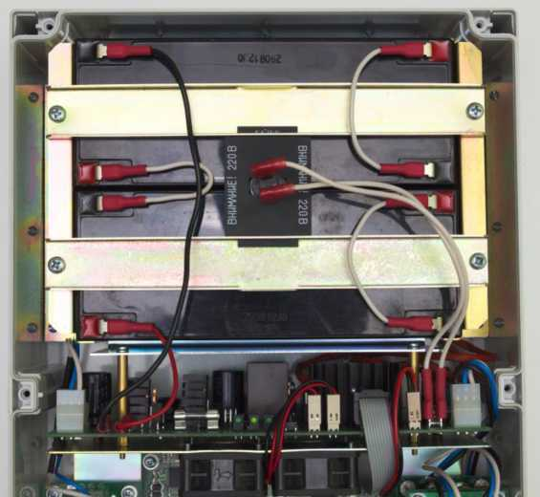

Figure 3.9.5. Connecting the battery

Place the battery into the battery compartment observing the polarity. Fix the batteries with metal holders, having previously placed a board with a thermal cell between them. The thermal cell must fit snugly against the battery housings. Connect wires (Figure 3.9.5).

IMPORTANT! When installing, do not short-circuit the battery holder. IMPORTANT! The thermal cell is supplied with a voltage of 230VAC.

* + 1. Monitoring the fan operation

Fans are installed into PSW-2G4F-UPS unit. They are switching on only at high temperature inside the unit. To check the serviceability of the fan control circuits, it is necessary to apply 230VAC to the switch and press the control button (figure 3.9.6). The fans must turn on. This test is recommended after installation of the device.

Fan control button

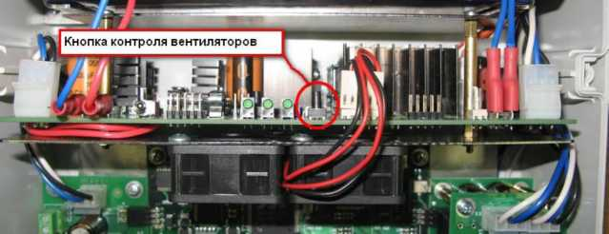

Figure 3.9.6. Checking the operability of fans.

1. Technical parameters

Gigabit Ethernet Ports

* 1000Base-X with SFP connector;
* Number of ports - 2;

Fast Ethernet Ports

* 10/100Base-Tx with RJ-45 connector;
* number of ports - 4;
* supports Auto-MDIX for the port 10/100Base-Tx;
* supports flow control of IEEE 802.3x;
* supports IEEE802.3af – 15.4 W at a port;
* supports Passive PoE – 15.4 W at a port;
* power budget of IEEE802.3af is not higher than 50W;
* data and PoE transmission distance – up to 100m.

Power supply

* unit supply voltage – 230VAC (from 187V to 253V);
* Max power consumption (for more details see section 8.1)
* for PSW-2G4F not more than 120W.
* for PSW-2G4F-UPS not more than 220W.
* battery characteristics (if included) of the PSW-2G4F-UPS
* Rated voltage 12V;
* capacity 2.2A * h;
* Dimensions 178х35х61 mm;
* number - 4 pcs.

Design

* Dimensions
* 240Х160х90 mm for PSW-2G4F;
* 240x360x120 mm for PSW-2G4F-UPS;
* weight
* maximum 2 kg for PSW-2G4F;
* maximum 8 kg for PSW-2G4F-UPS with the batteries;
* protection level against the external influences IP66;
* number of cable glands for cable diameter
* 4-8 mm – 5;
* 6-12 mm – 2.

Reliability

* mean time between failures is more than 75 000 hours (8,6 years);

1. Operation conditions

The switch PSW-2G4F is intended for 24-hour outside operation at ambient temperature according to the table 5 using industrial SFP modules.

Table 5. Operation temperature range

|  |  |
| --- | --- |
| Switch type | Operation temperature range |
| PSW-2G4F | -55 .. +50 °C* and above (-67..122 F)*, up to +65 °C with less load |
| PSW-2G4F-UPS | -45 .. +40 °C (-49 .. +104 F) |

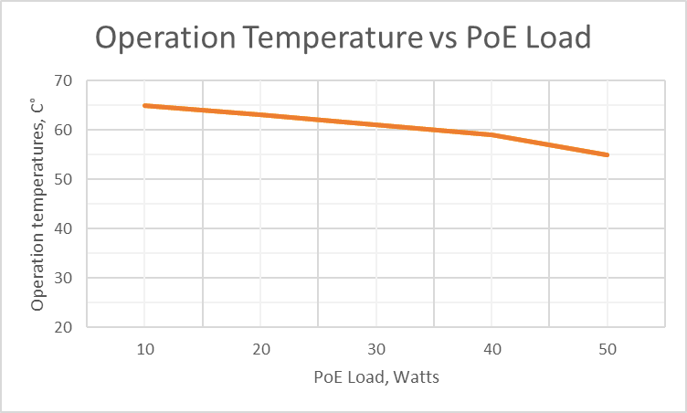*The maximum temperature depends on the load (see diagram)

Note 5.1:

Commutator PSW-2G4F maintains declared parameters at storage temperatures from -60 C to +50 C (-67 F to +122 F).

Note 5.2:

Observe and follow the storage conditions of the battery used.

It is recommended to install the switch in places protected from direct sunlight (for example, under canopies, on the shady side of buildings)

1. Presetting

IMPORTANT! Remove the PoE jumpers from the port to which you will connect the computer.

6.1. Restore switch to Factory Settings

Before starting work, put the PSW-2G4F switch into the default settings. For this you should press and hold DEFAULT button until DEFAULT indicator lights up. The switch by default has IP-address 192.168.0.1.

* 1. Setting the IP address

All software functions of the PSW-2G4F are available for management, configuration and monitoring using the built-in Web interface and Telnet. Next, there will be a description for WEB management. The configuration via Telnet is described in a separate document.

The switch can be managed from remote stations anywhere in the network via a standard Web browser (for example, Microsoft Internet Explorer). The browser is a universal access tool and can directly access the PSW-2G4F using the HTTP protocol.

Connect any port on the PSW-2G4F to an Ethernet network. Keep in mind that if the device is configured over a network, then the IP address of the management workstation must belong to the same IP network. For example, if, by default, the switch’s IP address is 192.168.0.1, then the IP address of the workstation should be 192.168.0.x (where x is a number from 2 to 254), the default subnet mask is 255.255.255.0.

Open the Web browser program and enter the IP address [http://192.168.0.1](http://192.168.0.1/).

Figure 6.2. Entering the IP Address of the switch

* 1. Setting Up Username and Password

Until the “Username” and “Password” are set, you will log in without entering this data. After the password is set, you will need to pass authentication at logging in.

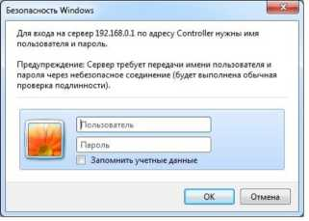

Figure 6.3. Entering Username and Password.

**Note that the Username and the Password are case sensitive.**

* 1. Configuring PoE on ports

PoE power configuration is carried out using jumper (see section 3.3). All connections must be made with the disconnected power 230VAC.

When you connect devices that do not support PoE (for example, PC), make sure that the jumper is removed from the corresponding port.

* 1. Enabling Preheating of camera housings

When the camera is turned on in cold conditions, it may not start or, even worse, fail. To solve this problem, use the Comfort Start function. To do this, go to the Special Function tab in the Comfort Start section and enable the option. By default, it is disabled. This function is available only with camera housings TFortis TH.

IMPORTANT! When this option is enabled, after the power is applied to the switch, the cameras will only turn on after time of Soft Start Time. To force the cameras to turn on, click on Manual Start.

* 1. Enabling backup protocols

If you connect the switches into a ring, then you need to enable the RSTP protocol. Otherwise, if alternative paths appear, your network will not work. By default, RSTP is disabled.

* 1. **Backup power supply configuration**

There are two power supply units in PSW-2G4F switch. Left PSU is designed to power the switch and the camera housing over PoE. Right PSU has two operation modes. If the 230VAC power supply backup is needed, place the RES_PWR jumper in YES position.

1. Device installation
   1. Unit mounting
      1. Installation of the unit on the wall

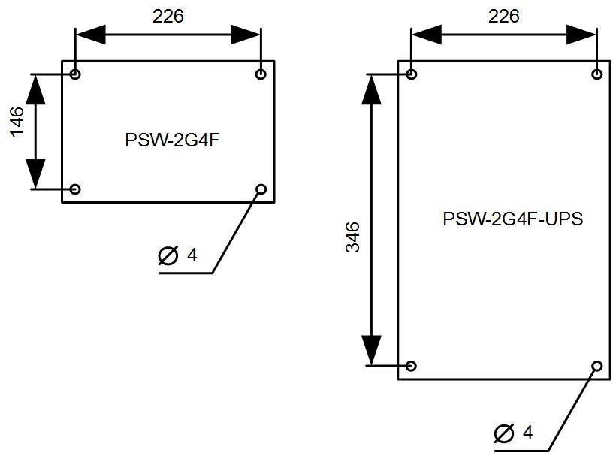The enclosure has four attachment points along the edges of the unit. The marking of the fastening for the installation of the product is shown on the Fig. 7.1.1

Figure 7.1.1. Marking of the fastening

IMPORTANT! Drilling of the housing leads to the sealing violation of the entire switch and, as a consequence, the loss of product warranty.

* + 1. Installation of the unit on the support

To install the PSW-2G4F on the support use TFortis bracket for PSW.

* + 1. Installation of the unit into TFortis CrossBox cabinet

Switches TFortis PSW-2G4F are made from techno-polymer with IP66 protection rating in a hermetic casing. This is quite enough to install devices in the open air. However, it is recommended to place PSW-2G4F switches into the cabinet because they can accommodate additional equipment (Optical Distribution Frame, Circuit Breakers and other user equipment). In addition, the external metal cabinet has vandal resistance. For TFortis PSW switches, it is recommended to use TFortis CrossBox cabinets with protection rating IP54. In these cabinets, Optical Distribution Frames have already been built in and there is a DIN-rail for Circuit Breakers.

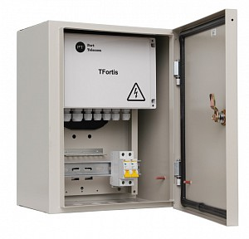

Figure 7.1.3.1 – TFortis CrossBox-1 cabinet with PSW-2G4F switch

Figure 7.1.3.2 – Tfortis CrossBox-2 cabinet with PSW-2G4F-UPS switch

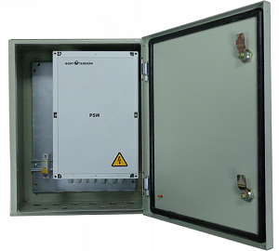

TFortis CrossBox Cabinet is purchased separately. Note that TFortis CrossBox is a recommended element, but not mandatory.

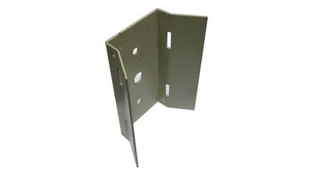It is recommended to use bracket for cabinet installation on the support. TFortis Bracket is a universal fastening on the support (pole, tower) for mounting cabinets and TFortis camera housings. The product is a metal molded plate, 3 mm thick. Bracket is fixed to the support with a cover band. Fixed to the support bracket is constantly in a spring-loaded condition. This allows withstanding a significant load without attenuation.

Figure 7.1.3.3 – TFortis bracket

* 1. Optic connection

There are no elements for welding of the optical fiber inside the PSW-2G4F. It is recommended to use External Optical Distribution Frames.

* 1. Power connection

The PSW-2G4F is connected to an AC source of 230VAC. The supply cable is brought into the unit through the cable gland, where it is connected to the terminal block of the power supply unit (Figure 7.3-1). Grounding of the device is required. The ground resistance must be no more than 4 Ohms.

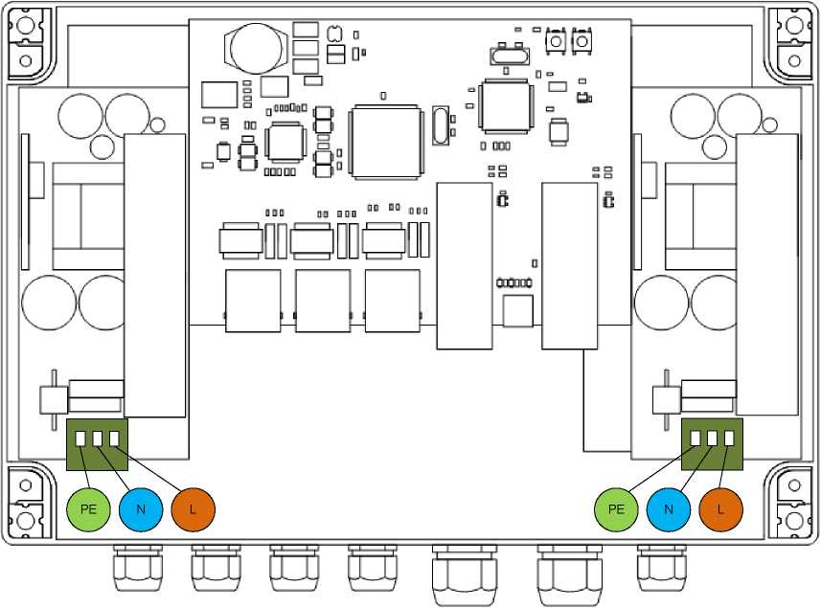

Figure 7.3-1. Power connection to the PSW-2G4F.

Please note that there are two power supply units in PSW-2G4F. Left PSU is designed to power the switch and cameras. Right PSU is designed either to power TFortis TH camera housings or to left PSU backup. The operating mode depends on the RES_PWR jumper (see 3.4 section).

The switch PSW-2G4F-UPS is also connected to an AC source of 230VAC. The supply cable is brought into the unit through the cable gland, where it is connected to the terminal block of the power supply unit (Figure 7.3-2).

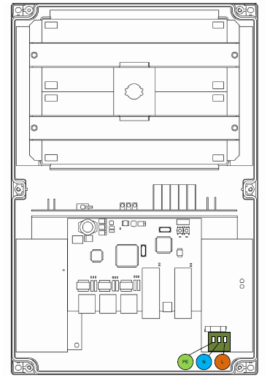

Figure 7.3-2. Power connection to the PSW-2G4F-UPS.

IMPORTANT! Grounding of the device is required. The ground resistance must be no more than 4 Ohms.

IMPORTANT! Do not allow printed circuit boards touching high voltage live wires. Failure in this case entails a loss of warranty.

IMPORTANT!

Since the switch contains switch-mode power supplies, it is a reactive load. During start-up, when charging input capacitors, a starting current appears and it exceeds the nominal value. In order to avoid false alarms of the protection devices, it is recommended to choose models with the characteristic C for a current of at least 4A.

* 1. Connection of video cameras

To the ports 1 to 4, connect cameras using a twisted pair. It is recommended to use a 4-pair shielded cable no worse than Category 5. The PSW-2G4F switch allows you to connect PoE video cameras with one cable, which drastically reduces the complexity of system installation.

The Ethernet cable is inserted through the cable gland into the unit, clipped and connected to the FE ports. For the convenience of clipping, it is allowed to remove the cable gland from the unit and then re-install it back to its original state. Unused cable glands should be closed off.

RJ-45 RJ-45

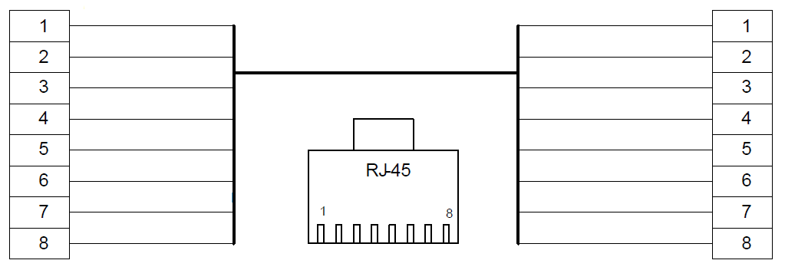

White Orange

Orange

White Green

Blue

White Blue

Brown

White Brown

Green

Brown

White Brown

Green

White Blue

Blue

White Green

Orange

White orange

Figure 7.4. Fanning out of the Ethernet cable.

1. Manufacturer’s warranty

Warranty period for the device – 36 months from the sale date, excluding accumulator batteries (For included batteries warranty period 12 months). The device is accepted for warranty maintenance and repair only in full completeness. Warranty repair is not performed in following cases:

* if warranty period has expired;
* if there is no label with serial number on the product housing, and also if serial number was changed, removed or illegible;
* if there are external and internal mechanical damages (chips, cracks, deformation, damage to the power cord, breaks and cracks of connectors), traces of chemicals, corrosive environments, liquids, heavy contamination, as well as the presence of insects or traces of their presence;
* due to non-compliance with the rules of connection and operation, as well as non-compliance of power specified in this operating manual;
* due to force majeure, third party action and other reasons that doesn’t depend on manufacturer.

1. **Technical support**

Technical support for the design of video surveillance systems, issues of operation and configuration of equipment is provided by email [tfortis@fort-telecom.ru](mailto:tfortis@fort-telecom.ru)

Technical documents are available on the website <https://tfortis.com/support/dokumentaciya-na-produkciyu/>

Appendix

Calculation of the power consumption

The consumption of the TFortis PSW switch is calculated by the formula:

|  |  |
| --- | --- |
| $$P_{SW}$$ | For the PSW-2G4F, the power consumption of the commutator board is not more than 5W.  For the PSW-2G4F-UPS, the power consumption of the commutator board and battery heater is not more than 45W. |
| $$P_{CAM}$$ | power consumption of the video camera. |
| $$P_{TH}$$ | power consumption of the heating element in the camera housing, taking into account the losses in the twisted pair. Not higher than 12W. |
| $$P_{TP}$$ | losses in twisted pair when powering the video camera |
| $$η$$ | efficiency output of the power supply unit TFortis PSW (not less than 85%) |

$$P=\frac{P_{SW}+\sum{(P_{CAM}+P_{TH}+P_{TP})}}{η}$$

**Note 1**

For some video cameras, the manufacturer does not specify power, but specifies PoE class. In this case, to determine $P_{CAM}$, you need to

use the table.

|  |  |
| --- | --- |
| Consumption class | max power |
| Class 0 and Class 3 | 13W |
| Class 1 | 3.84W |
| Class 2 | 6.49ВW |

**Note 2**

- the value is not large. At maximum load (13W), the maximum cable length (100 meters) and the worst cable (category 3), this value will be about 2W.

**Note 3**

$P_{TH}$ is not taken into account when video cameras are used in outdoor version, since the manufacturer indicates the total power consumption of both the video camera and the camera housing.

**Example**

It is required to calculate the power consumption of the TFortis PSW-2G4F switch when 3 AV1310 cameras in TFortis TH-02 camera housings are connected to it.

$$P_{SW}=5W$$

$$P_{CAM}=3W$$

$$P_{TH}=12W$$

$$P_{TP}=1W$$

$$η=0.8$$

$$P=\frac{5+\sum_{1}^{3}{(3+1+12)}}{0.8}=66.25W$$