
Multifunction Gigabit Managed Switch
with PoE+ (IEEE802.3at)
for IP- video surveillance systems
PSW-2G+

Operation manual

Version 9

ATTENTION!

Components of power supply units are under high voltage. Touching conducting components of active power supply units is forbidden.

When TFortis TH camera housings are connected, set mode PoE_B = Passive via the WEB-interface. By default, PoE_B = Auto.

If mode PoE_B = Passive is active at the port, connect computer to it only by 4-wire (2 paired) Ethernet cable.

Max load over PoE must be less than 160W.

SFP port operates only at 1000 Mbit/s. Fast Ethernet SFP modules will not operate.

For effective operation of lightning protection is required:
- high quality grounding according to the ELC;
- use of shielded twisted pair with shielded connectors RJ45;
- minimization of twisted pair and power cable length;
Table of Contents
1. Designation 4
2. Features………………………………………………..……………...5
3. Description 7
3.1. Appearance 7
3.2. Element arrangement 8
3.3. Power Supply over PoE 9
3.4. Optical Distribution Frame 10
3.5. Tamper sensor 10
3.6. Dry contacts………………………………………………………..11
3.7. Lightning protection 11
3.8. Additional functions 13
3.8.1. Cold start…………………………………………………………...13
3.8.2. Restart of video cameras at their hanging……………………...13
3.9. Diagnostic functions 14
3.9.1 Cable tester 14
3.9.2. Remote polling of video cameras 14
3.10. Power supply backup……………………………………………14
4. Technical parameters 15
5. Operation conditions 15
6. Presetting 16
6.1. Restore switch to Factory Settings 16
6.2. Setting the IP address 16
6.3. Setting Up Username and Password 17
6.4. Configuring PoE on ports 17
6.5. Enabling Preheating of camera housings 17
6.6. Enabling backup protocols 18
7. Device installation 18
7.1. Unit wall mounting 18
7.2. Mouning on the support………………………………………….19
7.3. Mouning in a cabinet……………………………………………..19
7.4. Optic connection 20
7.5. Power connection 20
7.5.1. Main power supply………………………………………………..20
7.5.2. Backup power supply…………………………………………….21
7.6. Connection of video cameras 21
8. Manufacturer’s warranty 22
9. Technical support…………………………………………………23

1. Designation
Device PSW-2G+ is an outdoor Multifunction Gigabit Managed Switch with built-in optical distribution frame. Designed for networking of IP- video surveillance systems.
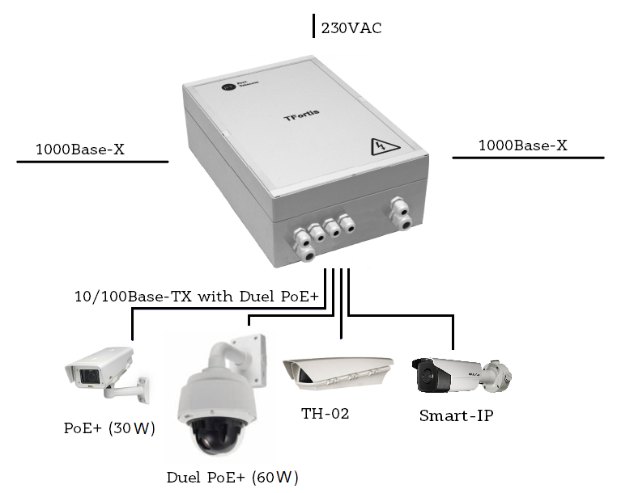
Figure 1. Connection diagram for the PSW-2G+

2. Features

Weatherproof version
The body of the device is made of a techno-polymer that is resistant to severe operating conditions. There is a protection from moisture and dust IP66.

Operation in extreme temperatures
The device has industrial hardware components that are characterized by an extended temperature range. Using industrial SFP modules in industrial version guarantees operation from -60°C to 50°C* and above (-76 to +122F)*, up to +70°C with less load.
*The maximum temperature depends on the load (see diagram in section 5. Operation conditions)

High- performance gigabit switch
The basis of the switch is a high-performance chip from Marvell, which provides processing of a large traffic coming from IР-video cameras.
PoE+ Support
All ports of the switch support PoE+ (IEEE802.3at). Thereby, you can power any PoE video camera via ordinary 4-paired twisted pair. This is especially important for PTZ-video cameras with power consumption up to 60W.

Power supply for Camera housings over PoE
Switch operating with TFortis TH camera housings powers both video camera and Camera housing via PoE (up to 30W per port).
Built-in Optical Distribution Frame
Presence of the Optical Distribution Frame allows distributing optics inside the device and connecting it to SFP modules.
Tamper sensor
There is an optical Tamper sensor inside the device for the detection and timely notification of unauthorized access.
Connection to 230VAC
Built-in power supply provides direct connection to the Power Supply 230VAC and excludes need in additional PSU. The unit provides place for installation of the Circuit Breaker.
Lightning protection
Built-in Lightning protection of Ethernet ports and 230VAC PSU reliably protects both the switch and connected video cameras from pulse disturbances induced by lightning discharges.
Cold start
Preheating of camera housings provides safe and guaranteed turn-on of video cameras in cold conditions.
Automatic restart of video cameras at their hanging
The switch controls operation of video cameras. If video camera is hanging, switch restart it automatically over PoE. This allows constructing non-attended IP- video surveillance systems.

Management via WEB-interface
A user-friendly and intuitive interface allows you quickly and easily configure the system.
Operation in a ring and in a chain
With two gigabit ports, you can connect the switches in a chain. STP/RSTP protocol support allows creating ring topologies, that significantly increases the fault tolerance of the system.

3. Description

3.1. Appearance
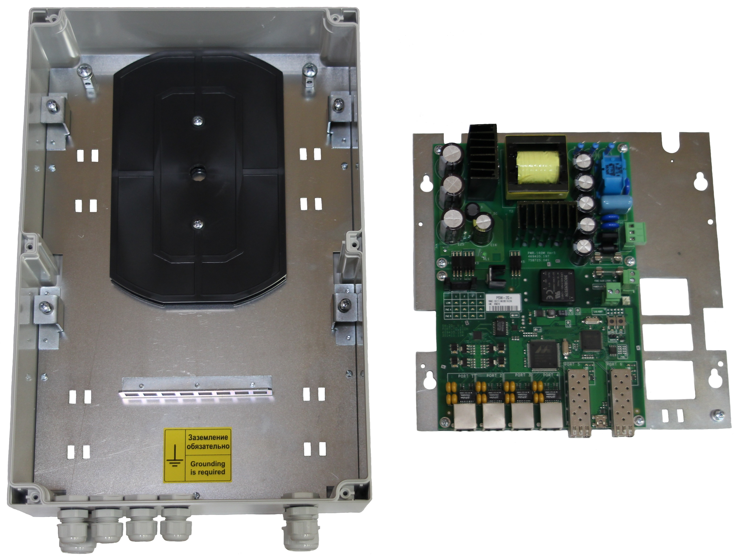
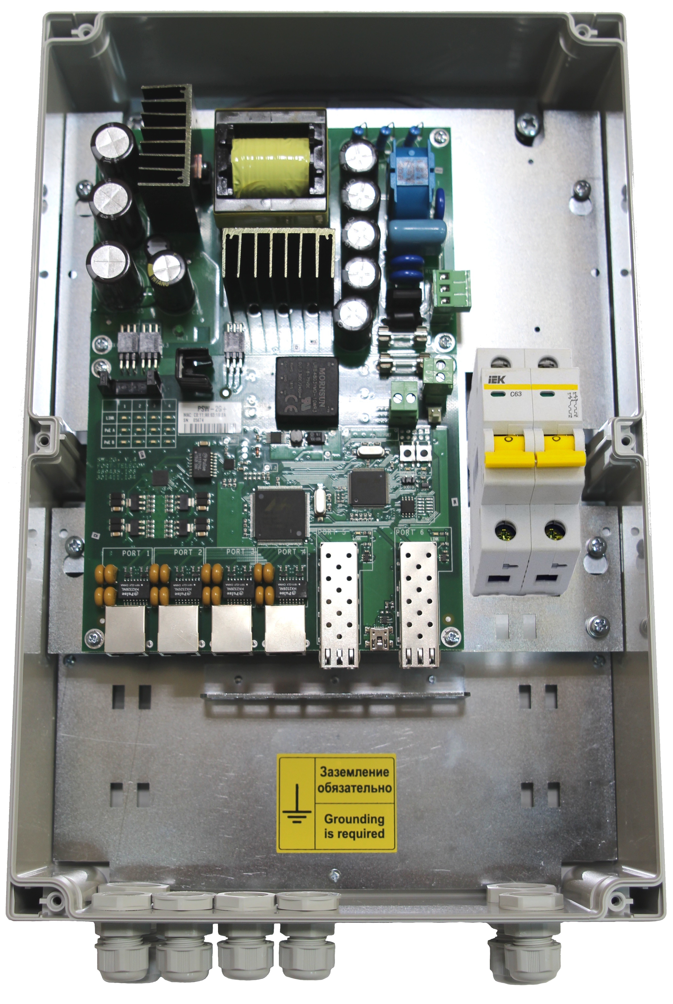
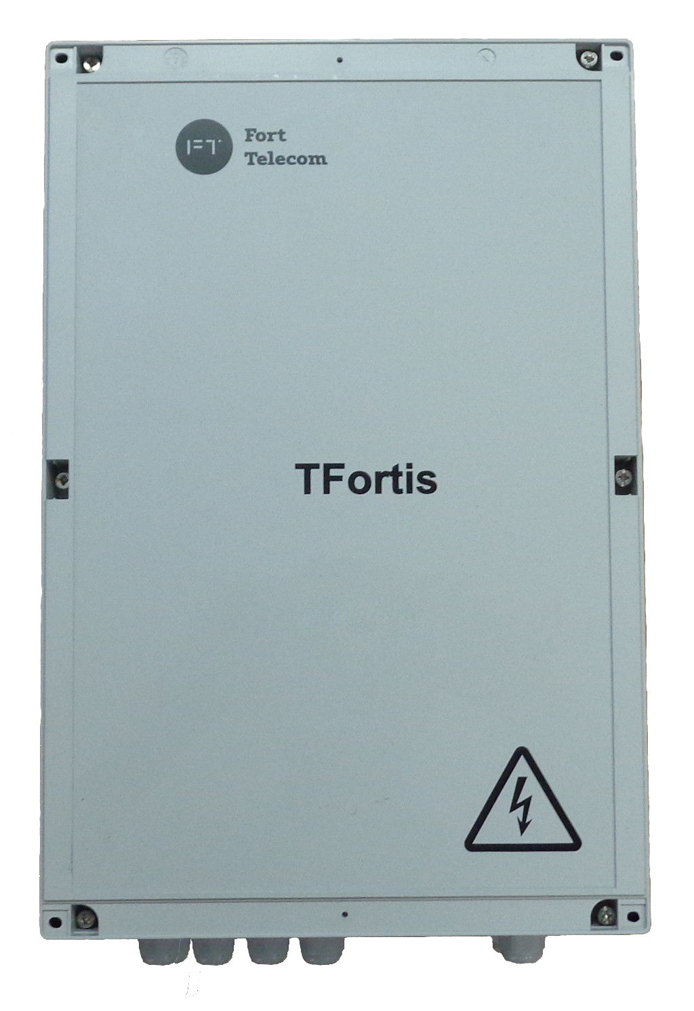

Figure 3.1-1. PSW-2G+ outside view
Figure 3.1-2. PSW-2G+ inside appearance

Figure 3.1-3. PSW-2G+ disassembled

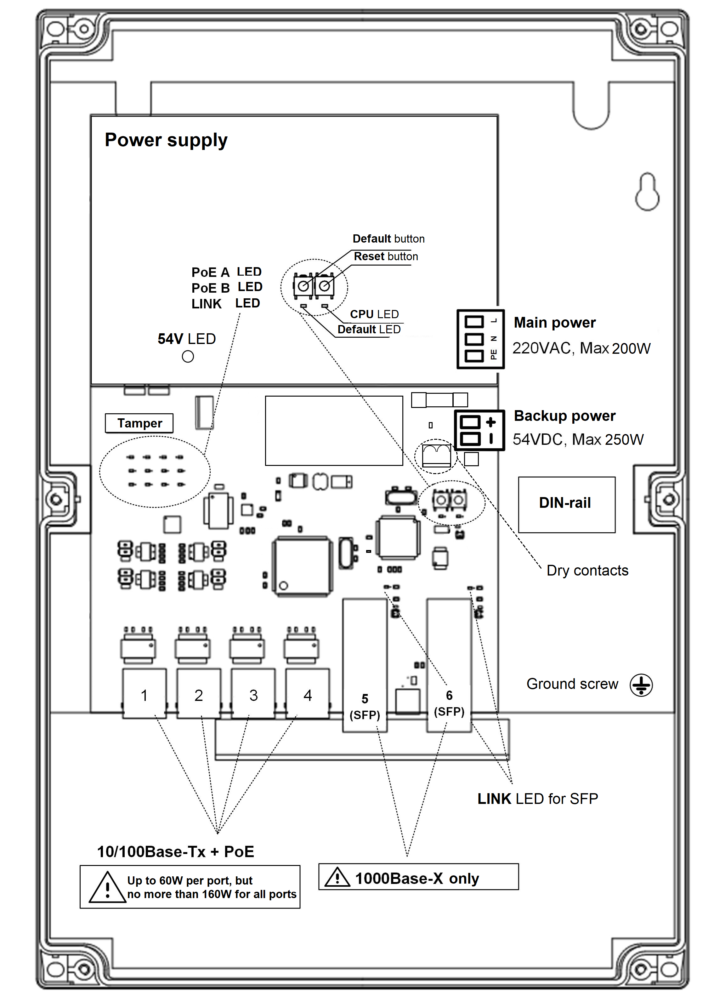
  - Element arrangement

Figure 3.2. Element arrangement of the PSW-2G+
During normal operation of the processor, a CPU indicator must light intermittently with a frequency of 2s. (1 sec. - on, 1 sec. - off.) DEFAULT Indicator is on, when the device is in factory settings (IP 192.168.0.1).
  - Power Supply over PoE
The switch PSW-2G+ supports power supply via double PoE+ (IEEE 802.3at), due to which it became possible to power any PoE-video camera over simple Ethernet cable. This is implemented as follows. Over pairs of wires 1,2 and 3,6 (mode A) is transmitted 30W and over pairs 4,5 and 7,8 (mode B) is also transmitted 30W. As a result, the total load is 60W. This power scheme is supported by energy-intensive devices. For example, outdoor PTZ-cameras with a declared capacity of 60W.
Since the PoE+ standard is backward compatible with ordinary PoE, the switch will power any IEEE802.3af video camera with up to 15W consumption.
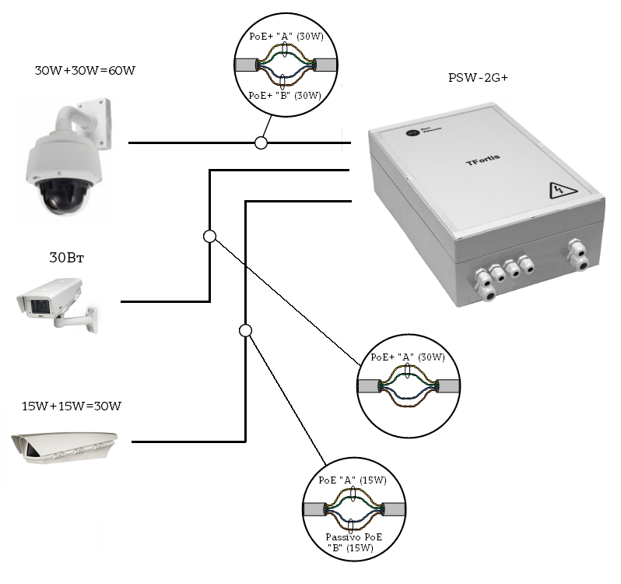
If you use TFortis TH camera housing, then it is necessary to set the power according to mode B to the Passive PoE mode via the WEB interface on the Port Settings tab. In this case, the video camera will be powered according to mode A and the camera housing will be powered according to mode B.

Figure 3.3 Power supply scheme over PoE in different cases
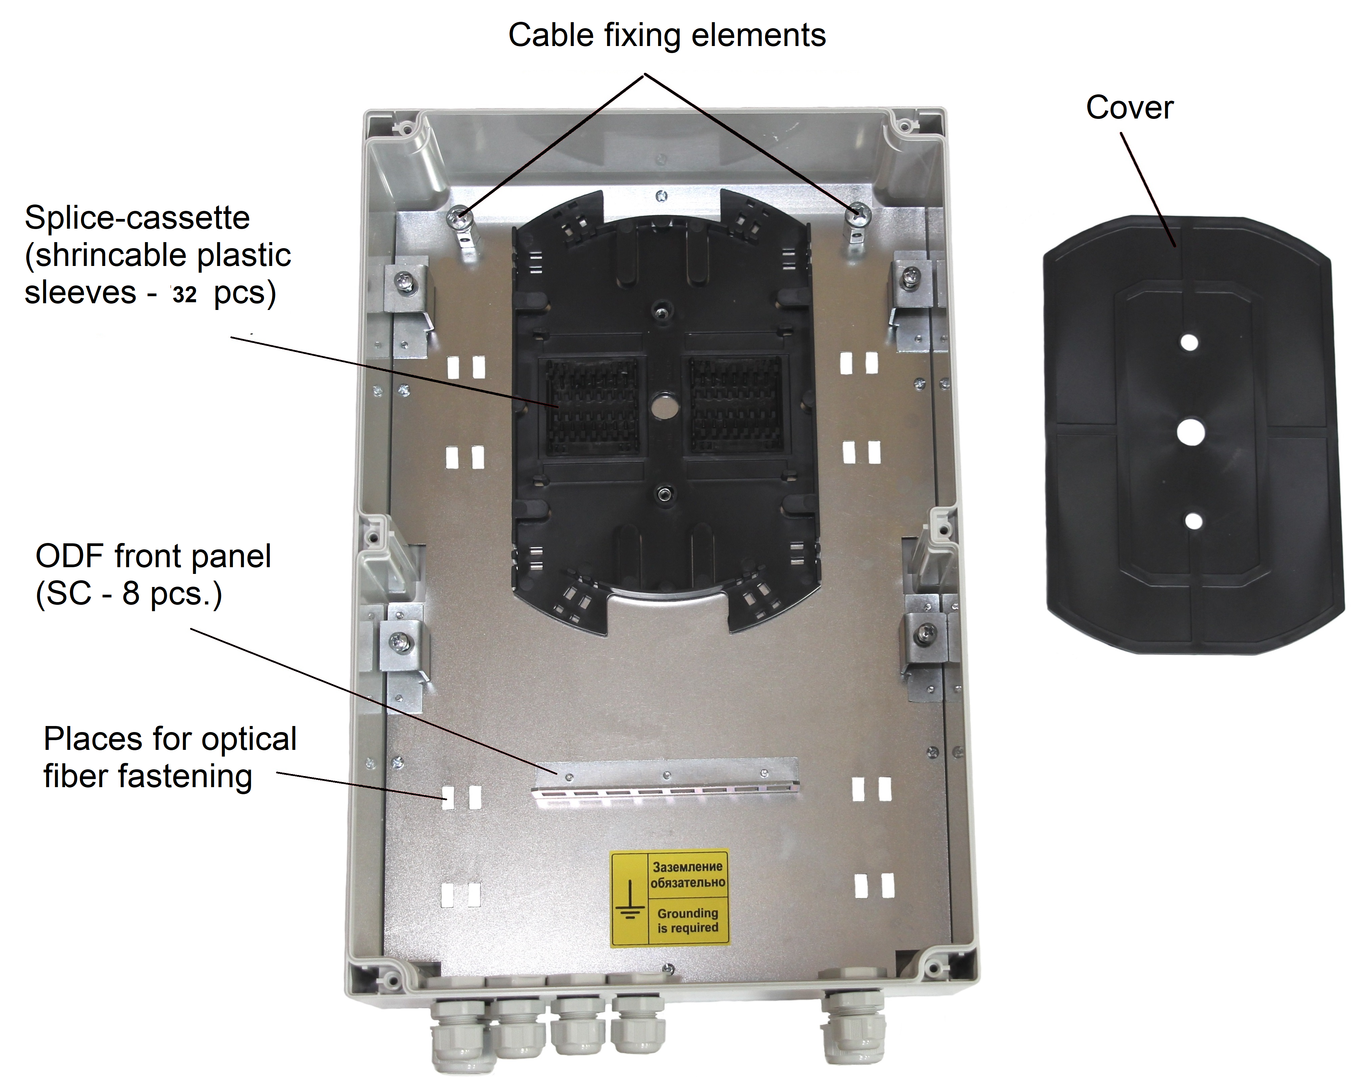
  - Optical Distribution Frame

Figure 3.4. Optical Distribution Frame
  - Tamper sensor
Inside the device, there is an Optical Tamper sensor (Figure 3.5-1). Unlike magnetically operated sealed switches and end switches, optical switch is more reliable. It does not stick, does not give a rattling. An operating principle is simple. When the unit is closed, special detector (Figure 3.5-2) installed on the unit cover breaks the optical flow. When the unit is opened, the detector exits from the sensor and activates it.
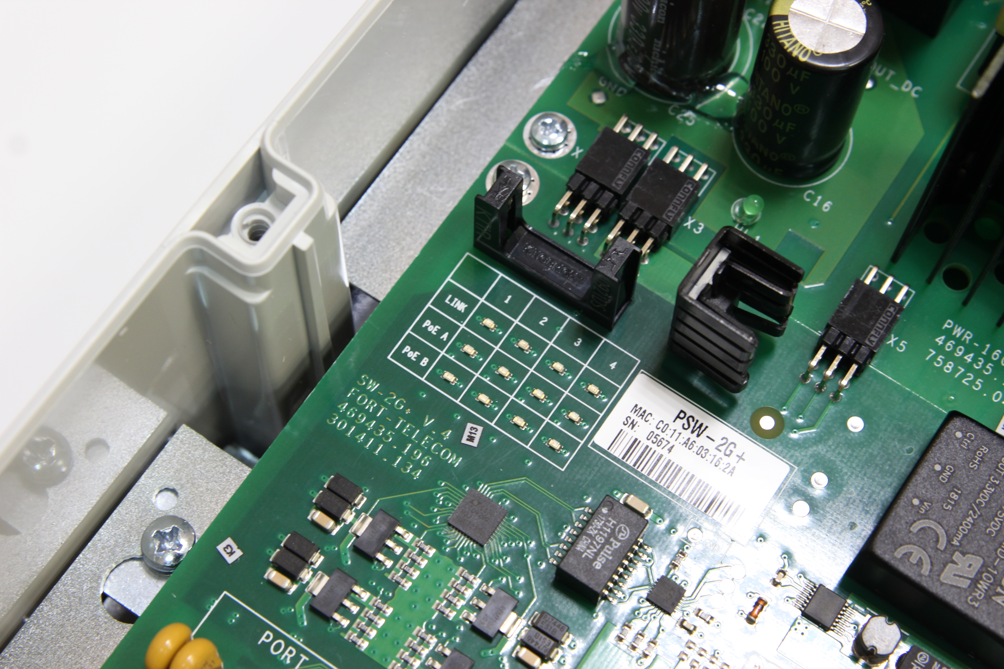
Figure 3.5-1. Tamper sensor on the board
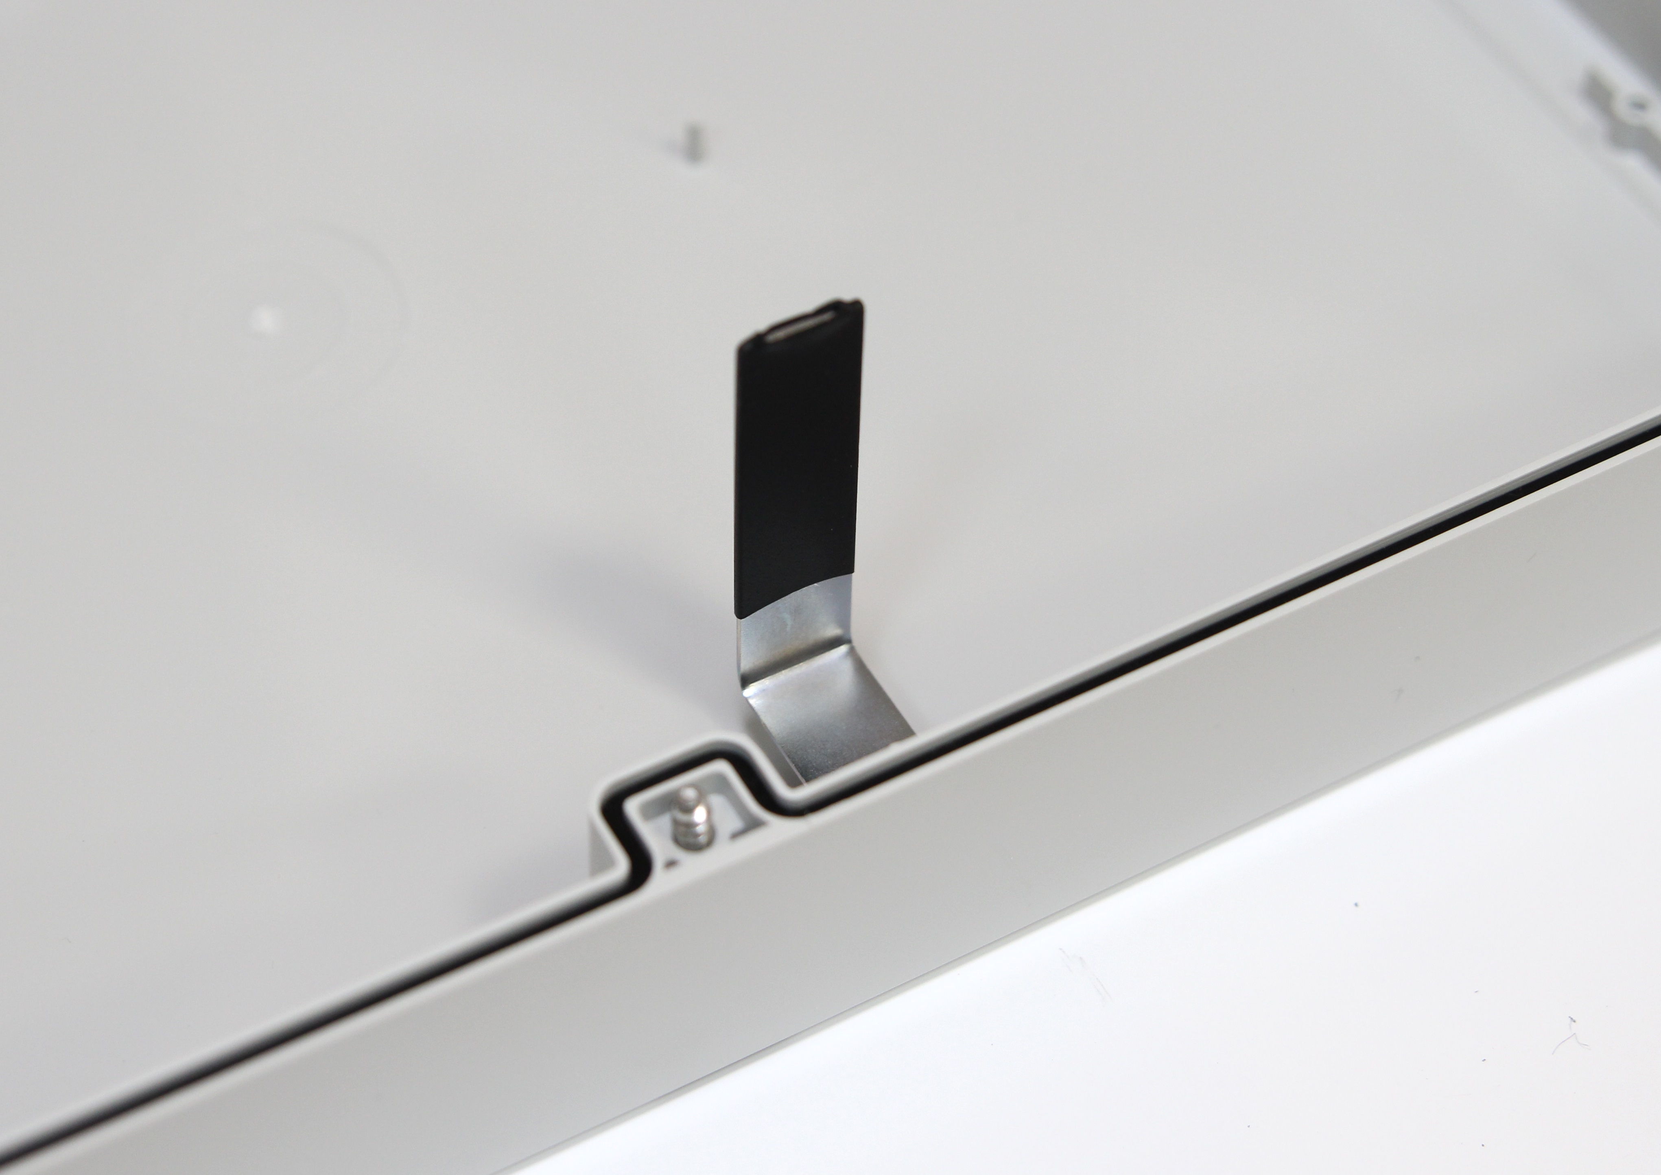
Figure 3.5-2. The door of the tamper sensor on the unit cover
IMPORTANT! Make sure that you correctly orient the cover of the unit when you close it. The detector should fall between tamper sensor beads.
  - Dry contacts

Dry contacts are intended for connecting external sensors (hermetically sealed contact, limit switch, motion sensor with relay output, etc.). The contact has a multi-purpose screw terminal. The states “normally closed” or “normally open” are set using WEB interface.
  - Lightning protection
The PSW-2G+ switch has in-built lightning protection modules that provide protection of Ethernet ports and power supply circuits 230VAC from common-mode and differential electromagnetic disturbances.
Switches are resistant to high-energy microsecond pulse interference in accordance with GOST R 51317.4.5 standard with a degree of rigidity according to Table 3.7-1 with performance criteria B.
Switches are resistant to dynamic changes in the voltage of the AC electrical network in accordance with GOST R 51317.4.11 standard according to Table 3.7-2 with the performance criteria B.
Table 3.7-1.
Port | Degree of rigidity according to the table 1 GOST R 51317.4.5 | Voltage pulse value, kW + 10%
Power lines of the switch “wire-wire” | 3 | 2
Power lines of the switch “wire-ground” | 4 | 4
Symmetrical communication lines of the switch “wire-ground” | 3 | 2

Table 3.7-2.
Types of impacts | Degree of rigidity at testing | Test voltage, % in, + 5 % | Amplitude of dynamic voltage changes, % Ur | Duration of dynamic voltage changes, periods (ms)
Voltage dips | 1 | 70 | 30 | 10 (200)
Voltage interruptions | 1 | 0 to 20 | 100 | 1 (20)
Voltage surge | 2 | 120 | 20 | 25 (500)
Note - Ur - rated supply voltage.

(Performance criterion B - temporary deterioration in the performance quality or termination of the established function with the subsequent restoration of normal functioning, carried out without the operator’s intervention) Maintainability is preserved during fluctuations in supply voltage from ~ 187 to ~ 253 V
  - Additional functions
    - Cold start
The most critical moment in the operation of the video camera is the process of its activation at low ambient temperature. Precisely a cold start can cause the failure of an expensive video camera. To avoid such cases, unit PSW-2G+ is implemented with preheating of TFortis TH camera housings. The essence of it is that after power is applied to the unit, initially will be powered heating elements of camera housings, and only then in 1 hour, the video camera itself. This delay allows obtaining comfortable conditions for starting video cameras and you will be able to save expensive equipment. Option Comfort Start is available via WEB-interface in the section Special Function.
    - Restart of video cameras at their hanging
The PSW-2G+ constantly monitors the connection of the video camera to the switch. There are three ways to determine the camera’s hanging:
- No connection to the video camera (Link)
- No response to service requests (Ping)
- Reducing the flow from the camera (Speed)
Video camera restart over the Link signal.
The PSW-2G+ switch constantly (1 time per minute) monitors the Link signal from the IP camera. If the switch does not detect the Link signal, then it starts a one-minute timer, when it ends, the connection is reconnected. If the Link signal does not appear, the PSW-2G+ removes power for 10 seconds and resets it, rebooting the camera. This mechanism can be described in other words. If the switch has not seen the Link signal from the video camera twice in a row with a 1-minute interval, then it reboots it. Option Auto Restart is available via WEB-interface in the section Special Function.
Video camera restart when there is no response to Ping.
The PSW-2G+ switch constantly (1 time per minute) polls the IP camera. If the switch does not receive a response, then starts a one-minute timer, during which the poll is repeated every 10 seconds. If the video camera does not response within a minute, the PSW-2G+ removes power for 10 seconds and resets it, rebooting the camera. If the camera has responded at least once, the switch decides that the camera is functioning properly and will start the poll cycle once again, referring to the camera 1 time per minute. Option Auto Restart is available via WEB-interface in the section Special Function. To use this mechanism, you will need to enter the IP address of your video camera. Make sure your video camera is responding to the PING (see diagnostic functions section).
Video camera restart when reducing the flow from the camera
The PSW-2G+ switch constantly controls traffic level (intensity) from the camera. If the activity falls below the set level the switch restarts the camera by removing power from the PoE. This function is enabled via WEB interface for a specific port.

3.9. Diagnostic functions
    - Cable tester
The PSW-2G+ has functions of a virtual cable tester (VCT - Virtual Cable Tester), which allows you to determine the break of the twisted pair, short-circuited twisted pair wires, unconnected cable to the video camera, distance between the defect and the switch. A cable tester diagnoses pairs that transmit data (1, 2 и 3, 6). Please note that the accuracy of the cable tester is ±2 meters.
By default, VCT operates on an average algorithm and does not take into account the specific features of a particular cable, which can affect the accuracy of the measurement. To improve the accuracy of the cable tester, it is recommended to calibrate it. Note that calibration is not recommended for cables with a length of less than 10 meters. See detailed information in «TFortis configuration manual» document.
    - Remote polling of video cameras
With the PSW-2G+ it is possible to ping any device in the network via the WEB-interface, which is convenient when solving network problems.

  - Power supply backup

There are two power supply inputs in PSW-2G+ switch. The main power supply (230 VAC) is put on the power supply unit, the backup power supply (54 VDC) is directly connected to the switch board. When the main power is lost, the device continues to work due to backup power. It is possible to use the device without power supply backup.

- Technical parameters

Gigabit Ethernet Ports
- 1000Base-X with SFP connector;
- Number of ports - 2;
Fast Ethernet Ports
- 10/100Base-Tx with RJ-45 connector;
- number of ports - 4;
- supports Auto-MDIX for the port 10/100Base-Tx;
- supports flow control of IEEE 802.3x;
- supports PoE+ (802.3at) over mode “A” (pairs 1,2 and 3,6) - 30W;
- supports PoE+ (802.3at) over mode “B” (pairs 4,5 and 7,8) - 30W;
- supports Passive PoE (power supply over mode B) - 30W;
- maximum output power per port 60W;
- total power must not exceed (PoE budget) 160W;
- transmission distance – up to 100m.
Main power supply
- unit supply voltage – 230VAC (from 187V to 253V);
- max power consumption 200W;
Backup power supply
- unit supply voltage – 54V DC (from 53V to 55V)
- max power consumption 250W

Design
- Dimensions 240x360x120 mm;
- Maximum weight 4 kg;
- protection level against the external influences IP66;
- number of cable glands for cable diameter 4-8 mm - 5, 6-12 mm - 2.
Reliability
• mean time between failures is more than 75 000 hours (8,6 years);
- Operation conditions

The switch PSW-2G+ is intended for 24-hour outside operation at outside temperature from -60 °C to +50°C* and above (-76 to 122F)*, up to +70°C with less load, using industrial SFP modules.
*The maximum temperature depends on the load (see diagram)

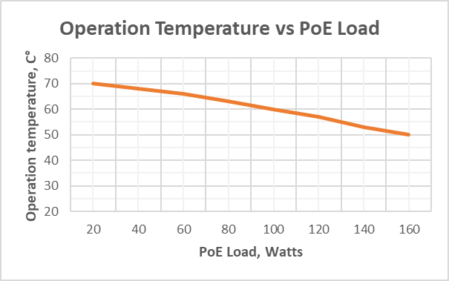
The switch PSW-2G+ maintains declared parameters at storage temperatures from -60°C to +50°C (-76 to 122F).

It is recommended to install the switch in places protected from direct sunlight (for example, under canopies, on the shady side of buildings)
- Presetting
  - Restore switch to Factory Settings
To restore switch to Factory Settings press and hold DEFAULT button until DEFAULT indicator lights up. The switch by default has IP-address 192.168.0.1.
  - Setting the IP address
All software functions of the PSW-2G+ are available for management, configuration and monitoring using the built-in Web interface. The switch can be managed from remote stations anywhere in the network via a standard Web browser (for example, Microsoft Internet Explorer). The browser is a universal access tool and can directly access the PSW-2G+ using the HTTP protocol.
Connect any port on the PSW-2G+ to an Ethernet network. Keep in mind that if the device is configured over a network, then the IP address of the management workstation must belong to the same IP network. For example, if, by default, the switch’s IP address is 192.168.0.1, then the IP address of the workstation should be 192.168.0.x (where x is a number from 2 to 254), the default subnet mask is 255.255.255.0.
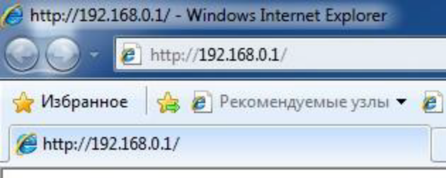
Open the Web browser and enter the IP address http://192.168.0.1.
Figure 6.2. Entering the IP Address of the switch

  - Setting Up Username and Password
Until the “Username” and “Password” are set, you will log in without entering this data. After the password is set, you will need to pass authentication at logging in.
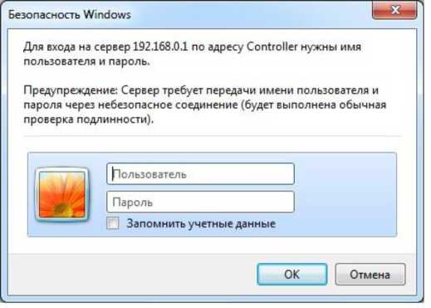
Figure 6.3. Entering Username and Password.
Note that the Username and the Password are case sensitive.
  - Configuring PoE on ports
By default, all ports are switched to PoE_A = Auto, PoE_B = Auto. When you connect a PoE-enabled video camera, it is automatically powered from the switch either by option A (pairs 1,2 and 3,6) or by option B (pairs 4,5 and 7,8).
If you want to connect a PoE video camera installed into the TFortis TH camera housing, you must set the PoE_A = Auto, PoE_B = Passive via the WEB interface on the Port Settings tab. The video camera will be powered as the option A, and the camera housing will be powered as the option B.
IMPORTANT! If mode PoE_B = Passive is active at the port, connect computer to it only by 4-wire (2 paired) Ethernet cable.

  - Enabling Preheating of camera housings
When the camera is turned on in cold conditions, it may not start or, even worse, fail. To solve this problem, use the Comfort Start function. To do this, go to the Special Function tab in the Comfort Start section and enable the option. By default, it is disabled. This function is available only with TFortis TH camera housing.
IMPORTANT! When this option is enabled, after the power is applied to the switch, the cameras will only turn on after time of Soft Start Time. To force the cameras to turn on, click on Manual Start.

  - Enabling backup protocols
If you connect switches into a ring, then you need to enable the RSTP protocol. Otherwise, if alternative paths appear, your network will not work. By default, RSTP is disabled.
- Device installation
  - Unit wall mounting
The enclosure has four attachment points along the edges of the unit. The marking of the fastening for the installation of the product is shown on the Fig. 7.1.
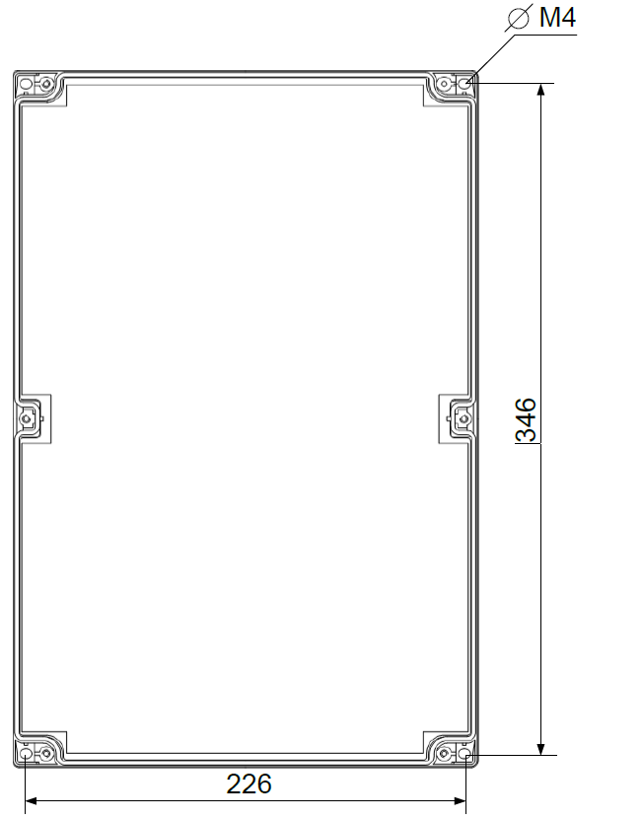
IMPORTANT! Drilling of the housing leads to the sealing violation of the entire switch and, as a consequence, the loss of the warranty.

Figure 7.1. Marking of the fastening
  - Mounting on the support

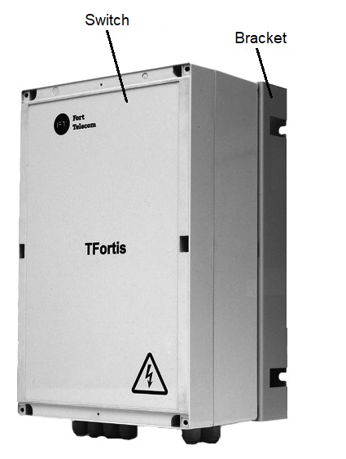
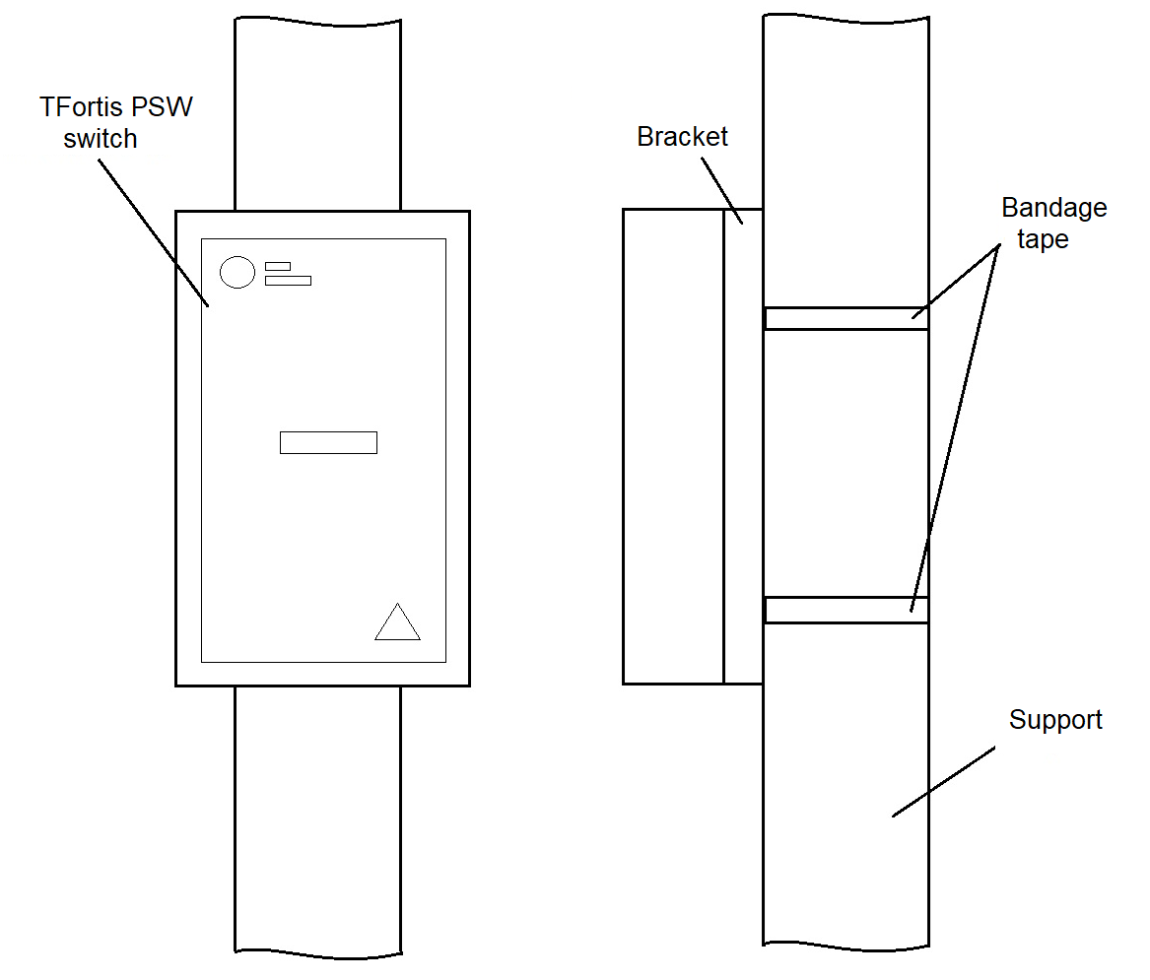
PSW-2G+ allows outdoor operation in the open air because device enclosure provides IP66 protection rating. When it’s required to install the switch on a support, the switch is mounted on a Bracket for PSW using a 30 mm bandage tape (https://tfortis.com/products/support-brackets/tfortis-support-bracket-for-psw/). For mounting on a Bracket M4 screws are used.

  - Mounting in a cabinet

When it is required to provide additional vandalism protection, we recommend to install the switch in metal outdoor cabinets TFortis CrossBox-2 and CrossBox-3.

PSW-2G+ provides for fixing to the rear false wall of the outdoor cabinet with four M4 screws.
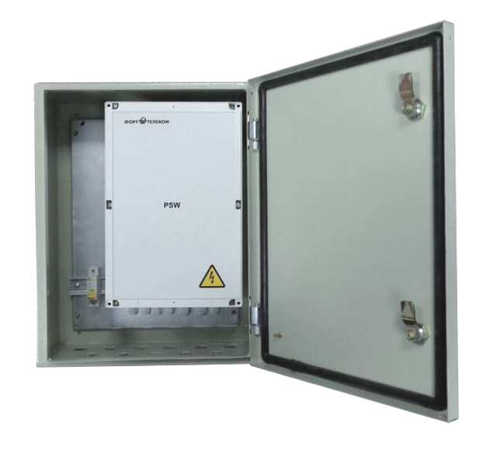
  - Optic connection
Inside the PSW-2G+ is installed Optical Distribution Frame. Optical cable is put into large cable glands that are on the lower tier of the unit. The optical cable is attached to the metal base of the distribution frame using nylon ties or metal clamps. For attaching the string are used metal columns with screws. Optical fibers fit in a splice-cassette designed for 32 shrinkable plastic sleeves. Welded pigtails are connected to SC adapters located on the plate. The optical patch cords then connect adapters and SFP modules. It is allowed to connect pigtails directly to SFP excluding unnecessary connections.
IMPORTANT! The kit does NOT include nylon ties, shrinkable plastic sleeves, pigtails, adapters.
IMPORTANT! SFP port operates only at 1000 Mbit/s. Fast Ethernet SFP modules will not operate.
  - Power connection
7.5.1. Main power supply
The PSW-2G+ is connected to the AC source of 230VAC. The supply cable is brought into the unit through the cable gland and connected to the terminal block of the power supply unit. It is possible to make this connection through a circuit breaker to remove high voltage when maintaining the switch. Calculation of the cable cross-section is based on the maximum consumption of the PSU that does not exceed 200W. Grounding of the device is required. The ground resistance must be no more than 4 ohms.
IMPORTANT! Do not allow circuit boards contacting high voltage live wires. Failure in this case entails a loss of the warranty.
IMPORTANT!
Since the switch contains switch-mode power supplies, it is a reactive load. During start-up, when charging input capacitors, a starting current appears and it exceeds the nominal value. In order to avoid false alarms of the protection devices, it is recommended to choose models with the characteristic C for a current of at least 4A.
7.5.2. Backup power supply
The PSW-2G+ has 54V DC backup power. The supply cable is brought into the unit through the cable gland and connected to the terminal block on the switch circuit board. Calculation of the cable cross-section is based on the maximum consumption that does not exceed 250W.
The switch can be operated without a backup power supply.
  - Connection of video cameras
To the ports FE, connect cameras using a twisted pair. It is recommended to use a 4-pair shielded cable no worse than Category 5. The PSW-2G+ allows you to connect any PoE video camera with one cable, which reduces the complexity of system installation.
The Ethernet cable is inserted through the cable gland into the unit, clipped and connected to the FE ports. For the convenience of clipping, it is allowed to remove the cable gland from the unit and then re-install it back to its original state. Unused cable glands should be closed off.
RJ-45 RJ-45
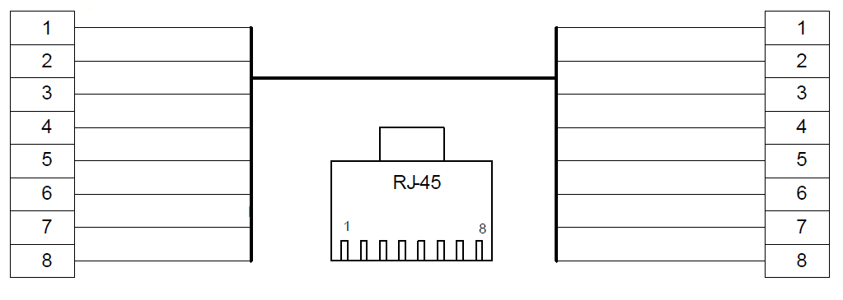
White Orange
White orange
Orange
White Green
Blue
White Blue
Green
White Brown
Brown
Orange
White Green
Blue
White Blue
Green
White Brown
Brown
Figure 7.6. Fanning out of the Ethernet cable.

8. Manufacturer’s warranty
Warranty period for the device – 36 months from the sale date. The device is accepted for warranty maintenance and repair only in full kit.
Warranty repair is not performed in following cases:
- if warranty period has expired;
- if there is no label with serial number on the product housing, and also if serial number was changed, removed or illegible;
- if there are external and internal mechanical damages (chips, cracks, deformation, damage to the power cord, breaks and cracks of connectors), traces of chemicals, corrosive environments, liquids, heavy contamination, as well as the presence of insects or traces of their presence;
- due to non-compliance with the rules of connection and operation, as well as non-compliance of power specified in the operating manual;
- due to force majeure, third party action and other reasons that doesn’t depend on manufacturer.

9 Technical support
To get technical support for the design of video surveillance systems, operation and adjustment of equipment:
Email at tfortis@fort-telecom.ru

All technical documents are available at: https://tfortis.com/support/dokumentaciya-na-produkciyu/

