Quick start
RS-485 transfer over Ethernet

Teleport-1 Teleport-2
Integration units

Manual Version 1
Firmware Version 1.0

© Fort-Telecom, Perm 2016

Teleport integration units have a wide functionality, but there are 2 main applications:
- RS-485 broadcasting via Ethernet
- broadcasting the state of dry contact inputs via Ethernet

Let's consider an example of application of Teleport-1 and Teleport-2 integration units for broadcasting RS-485.

In which cases should they be used?

Imagine a simple security and fire system. It's easy:
"Signal-10" is connected to "S2000M" via a twisted pair and the system is ready for operation. All loops are secured. The distance between the units may be up to 1200 meters, the system will operate smoothly.
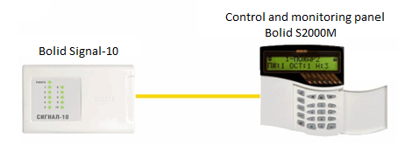
Fig. 1. Structure of a simple system

However, there may be situations where the distance between the units will be greater, or it may be unreasonable to install an additional twisted pair.
The only solution may be the use of fiber optic lines for the Ethernet network. In this case you can implement a virtual channel – pipe – via Ethernet for RS-485. To convert RS-485 signal to Ethernet and vice versa, Teleport integration units built into the existing network can be used without the need for any additional lines.
Figure 2 shows the structure of such integration into the existing network with TFortis SWU-16 central switch located on the side of the data acquisition and processing server and the PoE switch TFortis PSW-2G4F, located remotely from the data acquisition and processing server.

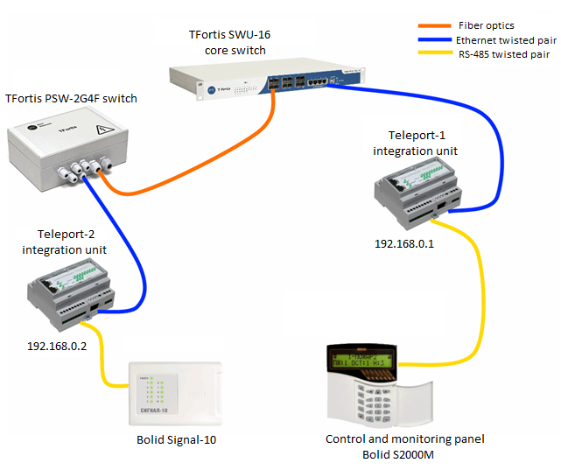

Fig. 2. Structure of the system

Teleport-2 integration unit converts RS-485
to Ethernet. Data passes through the nodal switch TFortis PSW, then via the optical cables through the central switch, then to Teleport-1 integration unit, where the reverse conversion Ethernet → RS-485 is performed.
To create a virtual RS-485 channel between two Teleport-1 and Teleport-2 units, they must be configured. The easiest way to configure is via the web interface. Default IP address is 192.168.0.1
Before connecting, make sure that the network card of the computer is on the same subnet as Teleport integration unit (192.168.0. *).
Start the web browser and enter the IP address 192.168.0.1 in the address bar.
Fig. 3. Connection to the integration unit

After connection, the main web interface page should display.
In general, the configuration process looks like this:
  - Configure the network settings
  - Register a remote device (For Teleport-1 it is Teleport-2 and vice versa)
  - Setting the RS-485 port to paired mode with a remote device.

Network settings
In the network settings of the integration unit, you should specify a unique IP address within the subnet. Let's say, the IP of Teleport-1 is 192.168.0.1, and the IP of Teleport-2 is 192.168.0.2. Change these fields as shown in Fig. 5.3.1.4. To do that, select Basic Settings → Network Settings in the side menu
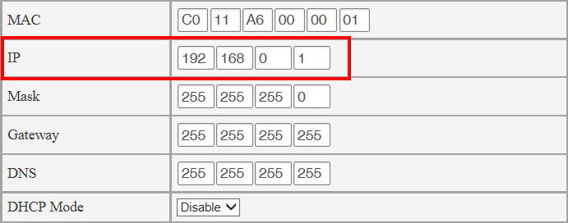
Fig. 4. Teleport-1 network settings

List of remote devices
To make Teleport-1 visible to Teleport-2, and Teleport-2 visible to Teleport-1, you should introduce them to each other. To do that, each unit has a list of remote devices. It stores all the devices that a local device can interact with.
Let's take Teleport-1 as an example. For it, the remote device is Teleport-2. Therefore, go to Teleport-1 web interface, tab Teleport Settings → Remote Devices. As we see, the list is empty yet. Add Teleport-2 to the list indicating its IP address, type (Teleport-2) and a user-defined description to ease the identification. Press Apply.

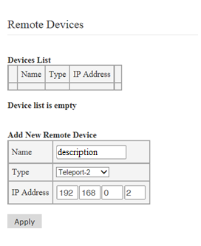

Fig. 5. Configuring Teleport-1 remote devices
As we see in Fig. 6, Teleport-2 has been added to the list.

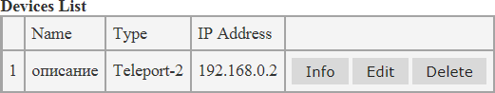
Fig. 6. List of Teleport-1 remote devices

A similar setting is made on Teleport-2 web interface.

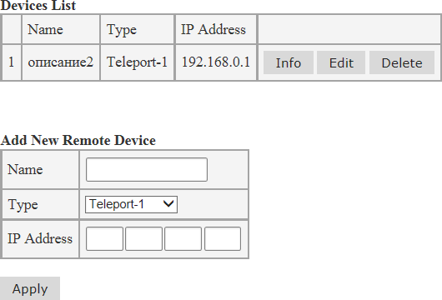

Fig. 7. Configuring Teleport-2 remote devices

Configuring RS-485 port
To configure RS-485 port, go to RS-485 → RS-485 Settings tab
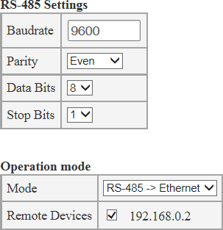

Fig. 8. Configuring RS-485 port of Teleport-1

In RS485 Settings section enter port settings, the same as for Signal-10 and S2000M. These devices require the following settings:
- 9600 bps
- parity check disabled
- 8 data bits
- 1 stop bit
By default, Teleport has the same settings, so they do not need to be changed. Leave them as they are.
Enter operating mode of the port in Operation mode section. We need to transfer data via Ethernet, so we select RS485->Ethernet mode – broadcasting mode. Indicate all the devices to which the data will be broadcast in the list of Remote Devices. In our case there is only one entry – Teleport-2. So we select it by setting a check mark.
Click Apply to apply the settings. Select the same settings on the other device.
Configuration is completed. Data from RS485 port of Signal-10 unit will be transparently delivered to RS485 port of S2000M unit.

Appendix 1
Summary table with settings

 | Teleport-1 | Teleport-2
IP address | 192.168.0.1 | 192.168.0.2
Subnet mask | 255.255.255.0 | 255.255.255.0
IP address of the remote device | 192.168.0.2 | 192.168.0.1
Type of remote device | Teleport-2 | Teleport-1
RS-485 operating mode | RS-485 → Ethernet | RS-485 → Ethernet
Remote device for RS-485 | 192.168.0.2 | 192.168.0.1

