Brief manual on firmware update

© Fort-Telecom, Perm 2017

There are 2 ways to update firmware in TFortis switches and integration units:
- updating through the web-interface
- updating through the TFTP server via Telnet
This document describes the first way, as it is easier.

To update the firmware, download the firmware archive file. Unpack it.
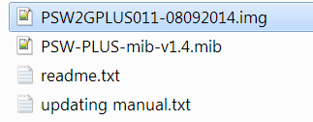
The firmware file has a *.img file extension.
Figure 1. *.img file
In the web-interface, go to the tab Update/Backup → Update Firmware
and choose the firmware file using the Browse button.
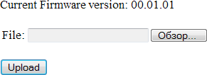
Figure 2. Press Browse
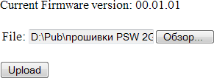

Figure 3. Pick a *.img file

Press the Upload button and wait until the file is copied into device internal storage.
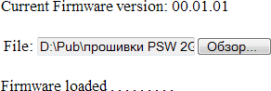

Figure 4. Wait when the file upload is finished

When the file is uploaded, press Update to update or
Cancel to cancel.

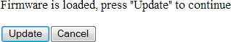
Figure 5. Press Update

After pressing Update, the update process will start. Do not reboot the switch or disconnect the power at this point, otherwise internal storage will be damaged.

Figure 6. Wait until firmware update process finishes
When the firmware update is finished, the switch will refresh the page automatically. If it does not happen, refresh manually by pressing F5.

